**CHAPTER-1**

**INTRODUCTION**

**M**aintaining good water quality in rivers and streams benefits both humans and aquatic ecosystems. Water is the essential element for humans to live. Equally, this principle applies to amphibians and aquatic animals. Any imbalance in water quality would severely affect the health of the humans and simultaneously affect the ecological balance among species. Hence, it is of prime importance to protect the quality of water.



**Fig 1.1** Water pollution

### 1.1 WHAT IS THE PROJECT ABOUT?

The inspiration of the proposed framework was to plan a remote framework to screen water quality in a most straightforward and practical way. This framework can break down some essential variables of water to take preventive measures for water quality support. The pH sensor and turbidity sensor are utilized to gather the pH and turbidity dimension of the water. With the utilization of wifi module, we can get the information from the rural and less developed areas. The sensors have the simple yield, consequently they are interfaced to simple contribution of the Micro-controller and the information are exchanged through the WIFI module. The PH and turbidity parameters thus calculated are stored in a tabular format and is shown on web pages. The parameters that are utilized to decide the nature of the water are the pH level and turbidity level.



**Fig 1.2:** water Testing

### 1.2 WHY CHOOSE THIS PROJECT?

Water pollution remains a key factor contributing to declining ecological health in aquatic ecosystems worldwide. In Australia, the state of Victoria is facing a major challenge in maintaining water quality in the freshwater systems. Nearly 80% of waterways in Victoria are in poor to moderate condition and there has been little improvement from previous years. Remediation efforts are hampered by the difficulty of diagnosing the causes of environmental degradation. Currently, low-resolution water quality monitoring is conducted, and water samples are collected at regular periods for chemical analysis in the laboratory. The disadvantages of this approach are data collection is patchy in space and time, so sporadic pollution events can easily be missed. it is time-consuming and expensive for personnel to collect water samples, return to the objective of our work is to develop a low-cost, wireless water quality monitoring system that aids in continuous measurements of water conditions.Our contribution in this work is the system-level integration of sensor signal processing, and sensor data management.

### 1.3 USEFULNESS TO SOCIETY**:**

1. Characterize waters and identify changes or trends in water quality over time.
2. Identify specific existing or emerging water quality problems.
3. Gather information to design specific pollution prevention or remediation programs.
4. determine whether program goals -- such as compliance with pollution regulations or implementation of effective pollution control actions -- are being met.

### 1.4 Brief thesis on each chapter :

**Chapter 1**: In this we have given the introduction to our project and who it is useful to the society.

**Chapter 2**: In this chapter we have done the literature survey i.e about the existing system paper works of almost 10 existing systems.

**Chapter 3:** In this chapter we have given the block diagarm of our system i.e what are input devices ,output devices and the Micro-controller used is Arduino Uno and to send the information from Tx to Rx we used WIFI IOT & GSM.

**Chapter 4:** In this we have explained each very components working principle,specification,pin configuration,

Usefulness to the project ,why only that component is used and finally the interfacing diagram of each component

**Chapter 5:** In this we have explained the overall circuit diagram of the project.

**Chapter 6**: In this we have explained the software part of the project and what are the software’s used and their explanation in detail.

**Chapter 7:** In this we have explained about the outcomes of the project i.e how the outputs are to displayed on the LCD or PC .

**Chapter 8:** In this we have explained about the advantages of the project over existing systems and the area of applications in which we can use this project.

**Chapter 9:** In this we have given the conclusion of the project and what are the other future advancements or improvements that can be done on the project.

**CHAPTER-2**

**LITERATURE SURVEY**

|  |  |  |
| --- | --- | --- |
| **Author Name** | **Name of the title** | **Components used** |
| Monira Mukta & Samia Islam | IoT based Smart Water Quality Monitoring System. | Internet Of Things,pH,electric conductivity,turbidity,arduino-uno. |
| A.N.Prasad, K. A. Mamun, F. R. Islam, H. Haqva. | Smart water quality monitoring system | Ph,conductivity sensors,controller,GSM |
| Kamarul Hafiz Kamaludin &  Widad Ismail | Water Quality Monitoring With Internet Of Things (IoT) | IoT, RFID, WSN and WQM. |
| Chengcheng Zhang, Jian Wu, Jiancheng Liu | Water quality monitoring system based on WIFI Module | Ph sensor,Temperature sensor  Turbidity sensor, WIFI module |
| Aravindan S.Rao, Stephan Martial, Jayavardhan Gubbi. | Design of Low-cost Autonomous Water Quality Monitoring System | Ph,Light,Temperature sensors  Arduino Mega 2650 |
| Vaishnavi V, Varshitha R C, Tejaswini M | Smart Water Quality Monitoring System | Wifi,Arduino uno,Ph,Turbidity  Temperature,Water level sensors. |
| Daigavane and Dr. M.A Gaikwad | Water Quality Monitoring System Based on IOT | Wifi,ArduinoAtmega 238,Ph,Turbidity,Temperature sensors |
| L. Lakshmanan, Jesudoss A, Sivasangari A, Sardar Maran and Mercy Theresa M | Analysis of the Water Quality Monitoring System | Micro-controller,Ph,Turbidity sensors,GSM. |
| Dong He  & Li-Xin Zhang | The Water Quality Monitoring System Based on WSN | Micro-controller,Ph,Turbidity sensors & Zibee |
| Supriya R. Khair  &  Revati M. Wahul | Water Quality Data Analysis and Monitoring System in IoT Environment | Arm based Micro-Controller,  Turbidity, Ph, Carbon dioxide  Sensor. |

**Table 1:** Paper work of the authors

1. **IOT BASED SMART WATER QUALITY MONITORING SYSTEM:**

Developed by “Monira Mukta & Samia Islam” This paper represents an IoT (Internet of things) based smart water quality monitoring (SWQM) system that aids in continuous measurement of water condition based on four physical parameters i.e., temperature, pH, electric conductivity and turbidity properties. Four sensors are connected with arduino-uno in discrete way to detect the water parameters. Extracted data from the sensors are transmitted to a desktop application developed in .NET platform and compared with the WHO (World Health Organization) standard values. Based on the measured result, the proposed SWQM system can successfully analyze the water parameters using fast forest binary classifier to classify whether the test water sample is drinkable or not.

They analyzed the measured data of temperature, pH and dissolved oxygen from water samples and results an inversely proportional relationship among them. An IoT based remote sensing system is introduced for collecting, monitoring and analyzing water quality in remote area.

The proposed SWQM system is able to read data from water samples by sensors through the Micro-controller and analyze them using machine learning algorithm to predict water quality. The proposed block diagram of SWQM system in consists of four different sensors connected with controller to measure four important physical parameters (pH, temperature, conductivity and turbidity) of water samples. The pH sensor SEN0161 is used to measure the presence of acidity or alkalinity of any solution in logarithmic scale. The digital temperature sensor DFR0198 provides accurate reading between –55 to 125ºC. To measure the electrical conductivity of water sample, the analog sensor DFR0300 is utilized. The recommended detection range of this sensor is 1 to 15 ms/cm within a temperature between 0- 40ºC. Turbidity sensor SEN0189 is used in the design to detect the presence of suspended particles by using light. The extracted data from these sensors are accessed by the controller arduino-uno and transfer them to the developed desktop application. Machine learning algorithm is implemented at the backend to predict the water quality based on the measured data. Since the system will predict either the test water sample is “Drinkable” or “Not Drinkable”, the fast forest binary classifier algorithm is employed. 60 different water samples have been collected from nearby tap, filter, soft drinks and other sources. The prediction accuracy of the designed system is compared for the experimented data.

The schematic circuit diagram of the hardware set-up of the proposed SWQM system. Except the temperature sensor, other three sensors are of analog type. Each sensor has three different color wires such as red, black and others. Here, red wires are for +5V power supply, black wires are for ground and others are used for data estimation. A breadboard is used for creating common points for ground and power supply separately. Then common node of ground is connected to the ground of arduino and same process is repeated for power supply. The analog sensors are connected to the analog pins and digital sensor is connected to digital pin of the controller.

1. **SMART WATER QUALITY MONITORING SYSTEM:**

Developed by “A.N.Prasad, K. A. Mamun, F. R. Islam, H. Haqva” Nowadays Internet of Things (IoT) and Remote Sensing (RS) techniques are used in different area of research for monitoring, collecting and analysis data from remote locations. Due to the vast increase in global industrial output, rural to urban drift and the over-utilization of land and sea resources, the quality of water available to people has deteriorated greatly. The high use of fertilizers in farms and also other chemicals in sectors such as mining and construction have contributed immensely to the overall reduction of water quality globally. Water is an essential need for human survival and therefore there must be mechanisms put in place to vigorously test the quality of water that made available for drinking in town and city articulated supplies and as well as the rivers, creeks and shoreline that surround our towns and cities. The availability of good quality water is paramount in preventing outbreaks of water-borne diseases as well as improving the quality of life. Fiji Islands are located in the vaific Ocean which requires a frequent data collecting network for the water quality monitoring and IoT and RS can improve the existing measurement. This paper presents a smart water quality monitoring system for Fiji, using IoT and remote sensing

technology.

The Smart Water Quality Monitoring System will measure the following water parameters for analysis;

Potential Hydrogen (pH), Oxidation and Reduction Potential (ORP), Conductivity and Temperature using a RS technology. While monitoring these parameters, it is perceived that one should receive a stable set of results. Therefore a continuous series of anomalous measurements would indicate the potential introduction of a water pollutant and the user will be notified of this activity with the aid of IoT technology. False positives, such as anomalous readings over a short period of time, will be recorded but not treated as an alert. Hence, with the successful implementation of this monitoring approach, a water pollution early warning system can be achieved with a fully realized system utilising multiple monitoring stations.

Initiatives have been taken all over the globe to develop projects based on sampling water to aid in controlling marine environments. It may not be specific to water pollution monitoring but similar concepts are involved. Libeliums Smart Water device monitors the status of an aquarium’s health in Europe. It specifically monitors parameters like pH, electro conductivity, oxidation/reduction potential (ORP) and temperature. A cloud based solution is developed to help in monitoring data in real time providing a fast and effective reaction in case of rising abnormalities. A similar example to that of this project can be seen in

the coastal water pollution monitoring initiative in the Gulf of Kachchh with the only difference being in terms of it having a much larger scope and vastly more expensive protocols deployed to counter the effects of the industrial development. Furthermore, locally there have been projects based around the conservation of the coral reefs. The Mamanuca Environment society’s (MES) Biannual Sea Water Monitoring Program has been around for 4 years whereby tests are carried out on seawater for faecal coliform (FC) bacteria, salinity and nutrients which helps in ascertaining the health of the surrounding reefs.Research indicates that projects of this nature are developed on a large scale with generous funding from reputable organizations. There is little indication of smallscale and inexpensive projects that have a similar role in places like marine jetties, cities and industrial rivers to preserve aquaculture and public health. By applying a strategic, cheap and methodical technique this project hopes to achieve this in an effort to sanitize our oceans.

1. **WATER QUALITY MONITORING WITH INTERNET OF THINGS (IOT):**

Developed by “Kamarul Hafiz Kamaludin & Widad Ismail” The paper suggests an Internet of Things (IoT) based system implementation by embedding the Radio Frequency Identification (RFID) system, Wireless Sensor Network (WSN) platform and Internet Protocol (IP) based communication into a single platform for water quality monitoring (WQM) purpose. The suggested radio frequency for the proposed WSN communication to be deployed in vegetation area is 920MHz. The measured water parameter in this proposed system is pH level by using an analog pH sensor. The ambient temperature is captured during pH measurement by using an analog temperature sensor. All the WSN nodes are deployed in a real environment at the lake in the campus area of Universiti Sains Malaysia (USM) for performance evaluation. Instead of using 2.4GHz ZigBee protocol, the 920MHz Digi Mesh protocol is proposed to be implemented for water quality monitoring in vegetation area due to its ability to surpass the signal attenuation. This novel proposed system prototype was evaluated in a real environment to ensure that the main functionality on pH measuring process is following the design requirements. Several

experimental analysis were conducted including the energy analysis and communication read range analysis to study the overall performance of the proposed system.

In general, the water quality monitoring process is a specific task carried out by the respective authorities to measure the water parameters whether it can be safely consumed by human, animals and plants or not. The basic observed water parameters for water quality determination are pH level, Dissolve Oxygen (DO), Chemical Oxygen Demand (COD), Biochemical Oxygen Demand (BOD), Total Suspended Solid (TSS) and Ammoniacal Nitrogen (NH3N).All these water parameters will be measured to determine the water quality before can be safely consumed. The ignorance of a few respective authorities in implementing proper water

monitoring technique had caused serious health problems to human due to the dirty water consumption . Therefore, an automated system with different wireless technologies Embedment for water quality monitoring including the RFID system, WSN platform and IP-based communication is proposed in this study.

The IoT keyword is very synonym with the latest wireless monitoring system in our daily life. From the healthcare to the environmental surveillances, the IoT system is widely used for a reliable data acquisition in a real-time monitoring process. There are several approaches of IoT communication available. According to, device-to-device and device-to-cloud are the two types of communication that applied in IoT system. Most

of the developed IoT-based systems utilize the second approach which is device-to-cloud for data storing and online monitoring. By employing the cloud storage, there will be no more hassle in managing the data storage facility which is requiring a highly skills person in ICT background. WSN as a component in the proposed IoT ecosystem allows machine-to-machine (M2M) communication in transmitting information through UHF band frequency of 902MHz to 928MHz with the utilization of 920MHz transceivers. Most of the WQM spots are located in vegetation areas with high radio signal attenuation whereas the Line-ofSight (LoS) communication is almost impossible to be established there. The WSN platform in the proposed system enables the RFID tags to communicate with dedicated system gateway in a simplified network topology, Digi Mesh instead of typical IEEE 802.15.4 ZigBee that is often used in wireless monitoring system. There is no parent-child relationship in Digi Mesh network. Thus, all WSN nodes can be turned into

sleep mode, resulting an efficient wireless monitoring system with ultra-less energy consumption throughout the WQM operation.

1. **WATER QUALITY MONITORING SYSTEM BASED ON WIFI MODULE:**

Developed by “Chengcheng Zhang, Jian Wu, Jiancheng Liu” Aiming at the problems of the current water quality detection system, a new type of real-time online water quality monitoring system solution based on the Internet of Things is proposed. This solution integrates the design of STM32 singlechip microcomputer, sensors, WiFi wireless transmission and remote water quality management. The system uses sensors to

monitor water quality turbidity, pH value, temperature and other parameters, and uploads the data to the management center through wireless communication. According to the analysis results, the water environment quality was measured, and water quality problems were pre-warned to prevent further spread of pollution, improve the scientificity and efficiency of water quality monitoring and management, and provide relevant departments with response strategies and management measures. This system has good real-time performance and strong practicability, and can be promoted and used in the future to promote the development of water environment monitoring.

The system adopts a modular design concept as a whole, which is mainly composed of a main controller, a sensor and a wireless communication module. The water quality parameters collected by the sensors are transmitted to the main controller, and the main controller detects the water quality information according to the water quality parameters, and uploads the water quality data to the remote management platform through

WiFi wireless transmission. Users can access the server through mobile phone applications or web clients, receive or query monitoring data, set alarm thresholds, the server will periodically push water quality data information to the mobile phone, and send abnormal water quality information to mobile terminals in the form of alarm text messages, So that users can check the water quality problems in a timely manner.

The ESP8266 WiFi module is a standalone SOC with an integrated TCP/IP protocol stack, allowing any

microcontroller to access your WiFi network. ESP8266 can host applications or offload all Wi-Fi network functions from another application processor . Each ESP8266 module is pre programmed with AT command set firmware. The Wi-Fi module provides a connection between hardware and software.

The system software part consists of a data monitoring terminal, a cloud server, and a mobile APP / Web client. The hardware terminal is mainly responsible for data collection and forwarding to the server. The user writes the alarm threshold to the server through the client. The server forwards the data to the monitoring terminal and reaches the alarm threshold set online.

The data collected by the sensor layer is processed and transmitted to the cloud server. The system platform mainly monitors pH, temperature, turbidity, etc., and sets alarm valuesfor each monitoring data to form alarm records. The system Authorized licensed use limited to Wireless network uses a SQL Server database with strong security and strong concurrency control to organize, store, and manage data, and establish a historical database and an interactive database through the SQL Server database. The historical database mainly stores water quality data collected by sensors, and there is at most one piece of data in the interactive database. The information collected by the sensors will be updated to the interactive database in real time. The interaction database is mainly used as an intermediary between the cloud server and

the web page. The web client reads information from the interactive database through the HTTP protocol and presents it to the client. Through these database functions, the safe and stable operation of the water quality monitoring system is guaranteed.

1. **DESIGN OF LOW-COST AUTONOMOUS WATER QUALITY MONITORING SYSTEM:**

Developed by “Aravindan S.Rao, Stephan Martial, Jayavardhan Gubbi.” Good water quality is essential for the health of our aquatic ecosystems. Continuous water quality monitoring is an important tool for catchment management authorities, providing real-time data for environmental protection and tracking pollution sources; however, continuous water quality monitoring at high temporal and spatial resolution remains prohibitively expensive. An affordable wireless aquatic monitoring system will enable cost-effective water quality data collection, assisting catchment managers to maintain the health of aquatic ecosystems. In this paper, a low-cost wireless water physio chemistry sensing system is presented. The results indicate that with appropriate calibration, a reliable monitoring system can be established. This will allow catchment managers to continuously monitoring the quality of the water at higher spatial resolution than has previously been feasible, and to maintain this surveillance over an extended period of time. In addition, it helps to understand the behavior of aquatic animals relative to water pollution using data analysis.

The objective of work is to develop a low-cost, wireless water quality monitoring system that aids in continuous measurements of water conditions. They contribution in this work is the system-level integration of biosensors, sensor signal processing, and sensor data management. In this regard, they developed a prototype sensor as one component of the Autonomous Live Animal Response Monitor (ALARM) currently under development at the Victorian Center for Aquatic Pollution Identification and Management (CAPIM). As an important component of the ALARM biosensor, our system was designed to measure a suite of biologically relevant physio chemical parameters in freshwater. We measured temperature, light in- tensity, pH, electrical conductivity (EC), total dissolved solids (TDS), salinity (SAL), dissolved oxygen (DO) and oxidation reduction potential (ORP). These parameters provide insights into the current status of changing water conditions and assist in identifying pollution sources. Their system was tested at CAPIM by measuring these parameters continuously for one month in parallel with a commercial water quality monitor.

Simultaneous water quality surveillance across multiple tributaries allows catchment managers to detect spatial trends in water conditions in real-time. Higher resolution data would allow instant diagnosis of pollution sources and greatly assist catchment managers in assessing the impact of remediation efforts, but the expense of deploying current monitoring technology at multiple sites is prohibitive. Therefore, there is a need for real-time, on-site, water quality monitoring systems which can deliver continuous data of high quality at an acceptable cost.

A prototype system is reported. This system was developed as one component of the Autonomous Live Animal Response Monitor (ALARM) toxicity biosensor, designed to be deployed in-stream for continuous monitoring.

In this work, the design and demonstration of a pro- totype low-cost, continuous water-quality monitoring system is described. The system uses low-cost sensors and open- source hardware aimed at providing continuous water quality measurements at lower cost. The system uses low-cost sensors and open-source hardware to deliver continuous measurement of water quality at substantially reduced cost. Preliminary re- sults demonstrate that with appropriate calibration and signal- processing, the prototype can maintain accurate results over an extended period of time. We conclude the prototype is suitable for field deployment to provide continuous long- term water quality measurement, both as a component of the ALARM biosensor, and as a stand-alone instrument. This system delivers reliable, continuous water physio chemistry data at much lower cost than existing technology, allowing catchment managers to substantially improve the spatial and temporal resolution of water quality surveillance. In addition to the explicit benefits in monitoring, it helps to understand the behavior of aquatic animals relative to water pollution using data analysis.

1. **SMART WATER QUALITY MONITORING SYSTEM:**

Developed by “Vaishnavi V, Varshitha R C, Tejaswini M” Water is one of the major compounds that profoundly influence ecosystem. But, nowadays it is been exploited heavily due to rapid industrialization, human waste and random use of pesticides and chemical fertilizers in agriculture, which leads to water contamination. Thus, a water monitoring system is necessary to observe the water quality in a large area such as lake, river, and aquaculture. As per the current world situation, Internet of Things (IoT) and remote sensing techniques are used in heterogeneous areas of research for supervising, congregate and analyzing data from the remote locations. In this paper, the suggested system is a minimal price real time water quality monitoring system in IoT environment. This system comprise of numerous sensors for assessing the physical and chemical parameter. The factors of water that can be assessed using these sensors are pH, turbidity, conductivity, dissolved oxygen. Using this system the real time quality of water bodies can be determined and the

data uploaded over the Internet are analyzed.

The crucial parameters that are supervised by the system are conductivity, temperature, water level, pH and turbidity.The block diagram of the inclusive real time water quality monitoring system in IoT environs.In this system, the sensors such as conductivity, temperature, water level, pH, turbidity sensor with a Wi-Fi module and a power supply is allied to the basic controller- Arduino UNO. The basic controller retrieves the sensor values which will be assessed by situating the sensors in distinct water samples and the data will be directed to the cloud by means of the WI-FI module. An android application recommended will be used to reveal the sensor values examined via cloud and warnings will be provided to user if the value outstrips the threshold value. The application can be used by users including water authorities which help them to check up the water state.As the values will be passed to users in ordered interims, based on the scale defined for each parameter, users can have knowledge of about the water state. If the water is unhygienic then the related authorities can take measures needed to make the water clean and usable, even the society can take requisite measures in order to reduce the contaminants present in water. These measures can boost the water quality which makes it more usable.

The paper depicts a brief survey on the technology used in the existing smart water quality monitoring system and describes the technology used for this system. It also includes the international status of the system. Comparative study of the different mode of technologies used for real time monitoring. By employing this recommended system, the related authorities can take measures to boost the water quality which makes it more usable. These measures can diminish the contaminants present in water, which in turn cut off the threats caused due to usage of unclean water for daily life, assuring the acceptable facets of water.

1. **WATER QUALITY MONITORING SYSTEM BASED ON IOT:**

Developed by “Daigavane and Dr. M.A Gaikwad” Water pollution is one of the biggest fears for the green globalization. In order to ensure the safe supply of the drinking water the quality needs to be monitor in real time. In this paper we present a design and development of a low cost system for real time monitoring of the water quality in IOT(internet of things).The system consist of several sensors is used to measuring physical and chemical parameters of the water. The parameters such as temperature, PH, turbidity, flow sensor of the water can be measured. The measured values from the sensors can be processed by the core controller. The Arduino model can be used as a core controller. Finally, the sensor data can be viewed on internet using WI-FI system.

In the 21st century, there were lots of inventions, but at the same time were pollution, global warming and so on are being formed, because of this there is no safe drinking water for the world’s pollution. Nowadays, water quality monitoring in real time faces challenges because of global warming limited water resources, growing population, etc. Hence there is need of developing better methodologies to monitor the water quality parameters in real time. The water quality parameters pH measures the concentration of hydrogen ions. It shows the water is acidic or alkaline. Pure water has 7pH value, less than 7pH has acidic, more than 7pH has alkaline. The range of pH is 0-14 pH. For drinking purpose it should be 6.5-8.5pH. Turbidity measures the large number of suspended particles in water that is invisible. Higher the turbidity higher the risk of diarrheoa, collera. Lower the turbidity then the water is clean. Temperature sensor

measures how the water is, hot or cold. Flow sensor measures the flow of water through flow sensor. The traditional methods of water quality monitor involves the manual collection of water samples from different locations.

Monitoring of Turbidity, PH & Temperature of Water makes use of water detection sensor with unique advantage and existing GSM network. The system can monitor water quality automatically, and it is low in cost and does not require people on duty. So the water quality testing is likely to be more economical, convenient and fast. The system has good flexibility. Only by replacing the corresponding sensors and changing the relevant software programs, this system can be used to monitor other water quality parameters. The operation is simple. The system can be expanded to monitor hydrologic, air pollution, industrial and agricultural production and so on. It has widespread application and extension value. By keeping the embedded devices in the environment for monitoring enables self protection (i.e., smart environment) to the environment. To implement this need to deploy the sensor devices in the environment for collecting the data and analysis. By deploying sensor devices in the environment, we can bring the environment into real life i.e. it can interact with other objects through the network. Then the collected data and analysis results will be available to the end user through the Wi-Fi.

1. **ANALYSIS OF THE WATER QUALITY MONITORING SYSTEM:**

Developed by “L. Lakshmanan, Jesudoss A, Sivasangari A, Sardar Maran and Mercy Theresa M”

Now a days many people are suffering from dangerous diseases which are caused due to impure water. In our project we are doing analysis for water quality monitoring system, it gives data about the quality of water, on a web page. The quality of water is determined using various sensors like PH sensor and turbidity sensor, connected to the Arduino family micro-controller. The Arduino software is written in embedded C

and GSM module is connected to the Arduino. The data will be transferred constantly from the remote sensor organize through micro-controller and wifi. Wifi module is used to send data to the web page via internet which is connected to the micro-controller. The total data regarding the purity of water is displayed in the web page and is Analysis in the form of graph, pie chart and values are given in the table. We transfer this information to cloud and clients can get to this information through web page application, client from anyplace can screen the data whenever.

The inspiration of the proposed framework was to plan a remote framework to screen water quality in a most straightforward and practical way. This framework can break down some essential variables of water to take preventive measures for water quality support. The pH sensor and turbidity sensor are utilized to gather the pH and turbidity dimension of the water. With the utilization of wifi module, we can get the information from the rural and less developed areas. The sensors have the simple yield, consequently they are interfaced to simple contribution of the Node MCU micro-controller and the information are exchanged through the wifi module. The PH and turbidity parameters thus calculated are stored in a tabular format and is shown on pc. The parameters that are utilized to decide the nature of the water are the pH level and turbidity level.

The Project “An IoT based system for water quality monitoring” has been successfully designed and experimented. We have seen the success of sensors in various fields; the same idea has been applied to this water quality monitoring system. In this paper we have analysis different water quality monitoring systems to do the same. All these techniques are expensive and difficult in terms of analysis and collecting the data.

1. **THE WATER QUALITY MONITORING SYSTEM BASED ON WSN:**

Developed by “Dong He& Li-Xin Zhang” The water quality monitoring system is designed for the need of environmental protection department in a particular area of the water quality requirements .The system is based on the Wireless Sensor Network (WSN) .It consists of Wireless Water Quality Monitoring Network and Remote Data Center.The hardware platform use wireless microprocessor CC2430 as the core of the node . The sensor network is built in accordance with Zigbee wireless transmission agreement. WSN

Sample the water quality, and send the data to Internet with the help of the GPRS DTU which has a built-in TCP/IP protocol.Through the Internet, Remote Data Center gets the real -time water quality data, and then analysis, process and record the data. Environmental protection department can provide real-time guidance to those industry which depends on regional water quality conditions, like industrial ,plant and aquaculture.The most important is that the work can be more efficient and less cost.

The entire system consists of two parts: the WSN and Remote Data Center. Frist WSN collects water quality data,and then send the data to Remote Data Center with the help of GPRS DTU.

This design is expounded a new type of water quality monitoring system based on the WSN., The sensor nodes contain many different sensors modules ,like the modules of PH value, water temperature, water quality, turbidity value.The system is always in standby mode until the off-chip RTC wake the nodes up. The whole nodes's average current consumption will be less than 110 uA in this way.Even though using two

ordinary number 5 batteries,it can work steady upto six months or more. At the same time ,using the GPRS DTU which has a built-in TCP/IP protocol to connect zigbee network and Remote Data Center Simplify the design.Combining with controling and processing of Remote Data Center , the system can be a long-term, stable and real-time regional water quality monitor.

1. **WATER QUALITY DATA ANALYSIS AND MONITORING SYSTEM IN IOT ENVIRONMENT:**

Developed by “Supriya R. Khair & Revati M. Wahul ”Water quality monitoring is an important aspect to provide safe drinking water to the environment and keep the naturally gifted resource safe from getting contaminated. Old method used for water quality monitoring is to send gathered samples to the lab and then test them to verify the different water parameters. The process may cause the potential errors as well as it is timeconsuming and not the cost-effective solution. Solution need to realtime for the process of data acquisition, transmission, and processing of different parameters. This paper represents the system which is

cost effective, less time as well as less power consuming solution for water quality monitoring with the help of innovative technology such as: Internet of Things, Wireless sensor network, Modern communication technology and data analysis techniques which will provide you the alert and preventive action to take in case of an emergency. Real-time water quality monitoring system implemented with various sensors (Parameters: Carbon Dioxide, pH, Turbidity, Temperature, Water Level) which will help to gather water

parameter, ARM-based micro-controller (STM32 Nucleo-board) which will convert the analogue signal to digital signal, Zig-Bee module which is used to send the data to personal computer, then data analysis operation takes place which will notify the user wirelessly. The system keeps check on pollution of water as well as keep track through analysis on data optimized with the help of optimization data fusion algorithm, and if required, then alert the user to take the preventive action time to time.

The system which can be utilized in a distant area to assemble the information concerning, water turbidity, water level, water PH, water temperature, and carbon dioxide quantity present on the top layer of water. system evolve in process of achieving a required result of analyzing and monitoring the water quality and helps to use new emerging technologies such as Wireless sensor network, IoT (Internet of Things), different communication techniques and different data analysis techniques which will provide an alert in case of an emergency.Using ARM based microcontroller that is STM32 Nucleo board improved the performance as well as a cost-efficient solution for water quality monitoring. We improve the performance of system wireless sensors networks is used. Zig bee protocol helps to communicate on remote location for data transfer to personal computer, then graphical representation of data helps to provide environment for safe drinking water.

Applications of the work can be given to analyses the impact happen in water quality due to petroleum-based industry, metal-based industry, sewage treatment, acid-based industry, land clearing, stock control, pest and weed control, fertilizer application, lawn and park care, light industry, household chemicals. System will provide you the potential impact happen like Loss of species, Degraded habitat, Loss of species, Threat to public health, degraded habitat, reduced biodiversity, fish kills, algal blooms, excess nutrients and this will be communicated with the help of different parameters measured via system like, turbidity, dissolved oxygen, pH, dissolved organic carbon. System requires Microsoft Visual Studio, STM32CubeMX, SSMS (SQL Server Management Studio) to be installed in the system with the version 1.1 and onwards. At the point when a client is introducing this system on their PC, It might realize that this applications will keep

running on the Visual Studio stage, once you stack the task.

**CHAPTER-3**

**BLOCK DIAGRAM AND EXPLANATION**

**3.1 BLOCK DIAGRAM:**

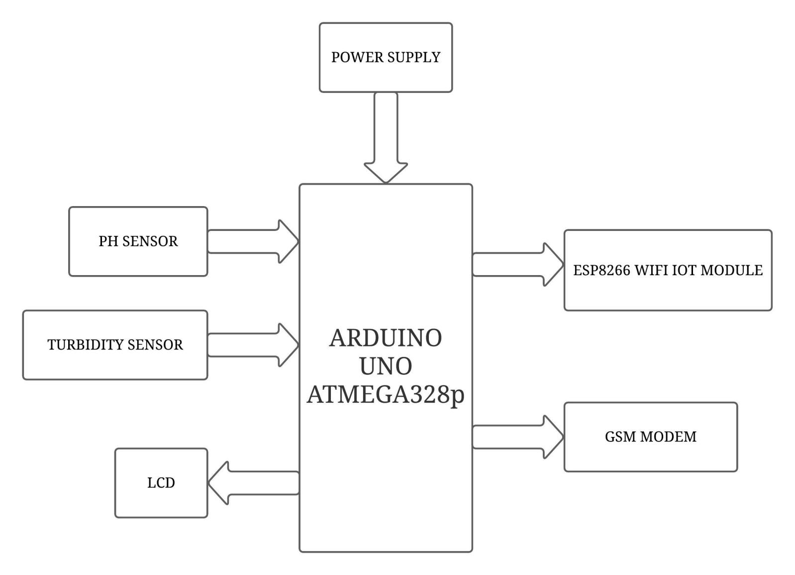

**Fig 3.1:** Block Diagram

**3.2 EXPLANATION:**

* **POWER SUPPLY:** It is used to provide 5V DC Power to the kit. It is necessary for the functioning of the kit.
* **LCD:**It is used to display multiple characters. Based on the predefined code and input signal, it gets an input from Arduino to display the information.
* **GSM:** It is used to send messages to the registered mobile number based on the conditions in the code. It is an output signal from Arduino.
* **ARDUINO UNO:** It is used to provide required outputs from input signals. It has a predefined code that compares input signals with values in it and stimulates output response accordingly.
* **WIFI IOT MODULE:** ESP8266 is a low-cost Wi-Fi microchip, with a full TCP/IP stack and Micro-controller capability & a Serial/UART to WiFi module is a great way to connect Arduino Uno to a WiFi network.
* **PH SENSOR:** It is one of the most essential tools that's typically used for water measurements. This type of sensor is able to measure the amount of alkalinity and acidity in water and other solutions.
* **TURBIDITY SENSOR:** The turbidity probe works by sending a light beam into the water to be tested. This light will then be scattered by any suspended particles.

**CHAPTER-4**

**HARDWARE COMPONENT**

**4.1 Arduino UNO:**

[Arduino Uno](https://en.wikipedia.org/wiki/Arduino_Uno) is a Micro-controller board based on the atmega328p . It has 14 digital input/output pins (of which 6 can be used as PWM outputs), 6 analog inputs, a 16 MHZ quartz crystal, a USB connection, a power jack, an ICSP header and a reset button. It contains everything needed to support the Micro-controller, simply connect it to a computer with a USB cable or power it with a ac-to-dc adapter or battery to get started.. You can tinker with your uno without worrying too much about doing something wrong, worst case scenario you can replace the chip for a few dollars and start over again.

"Uno" means one in Italian and was chosen to mark the release of [Arduino software (IDE)](https://www.arduino.cc/en/software) 1.0. The uno board and version 1.0 of Arduino software (IDE) were the reference versions of Arduino, now evolved to newer releases. The uno board is the first in a series of USB Arduino boards, and the reference model for the Arduino platform; for an extensive list of current, past or outdated boards see the Arduino index of boards.

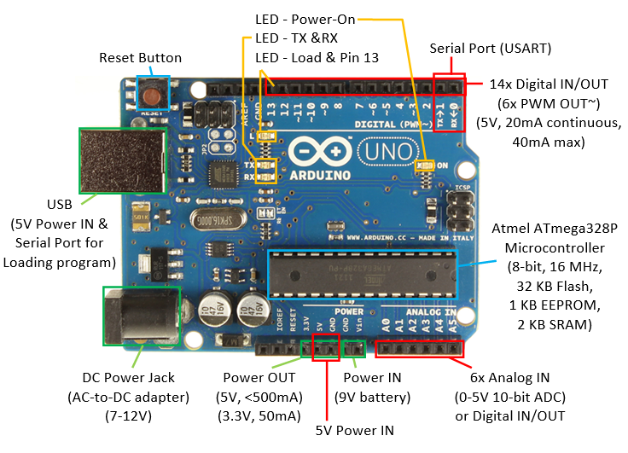

**Fig 4.1:** Arduino UNO Atmega328p

**4.1.1 TECHNICAL SPECIFICATIONS:**

|  |  |
| --- | --- |
| Micro-controller | ATmega328P |
| Operating Voltage | 5V |
| Input Voltage (recommended) | 7-12V |
| Input Voltage  (limit) | 6-20V |
| Digital I/O Pins | 14 (of which 6 provide PWM output) |
| PWM Digital I/O Pins | 6 |
| Analog Input Pins | 6 |
| DC Current per I/O Pin | 20 mA |
| DC Current for 3.3V Pin | 50 mA |
| Flash Memory | 32 KB (ATmega328P)  of which 0.5 KB used by  bootloader |
| SRAM | 2 KB (ATmega328P) |
| EEPROM | 1 KB (ATmega328P) |
| Clock Speed | 16 MHz |
| LED\_BUILTIN | 13 |
| Length | 68.6 mm |
| Width | 53.4 mm |
| Weight | 25 g |

**Table 2 :** Specifications of Arduino

**4.1.2 FEATURES OF ARDUINO:**

**Table 3:** Features Table

|  |  |
| --- | --- |
| **Parameter** | **value** |
| CPU type | 8-bit AVR |
| Performance | [20 MIPS](https://en.wikipedia.org/wiki/Instructions_per_second) at 20 MHz |
| Pin count | 28 |
| Maximum operating frequency | 20 MHz |
| Number of touch channels | 16 |
| Hardware QTouch Acquisition | No |
| Maximum I/O pins | 23 |
| External interrupts | 2 |
| [USB](https://en.wikipedia.org/wiki/USB) Interface | No |
| Operating Temperature | -40 C to +85 C |
| Timer (3) | 8-Bit x 2 & 16-Bit x 1 |
| Enhanced Power-on Reset | Yes |
| Power Up Timer | Yes |
| I/O Pins | 23 |
| Manufacturer | Microchip |
| SPI | Yes |
| I2C | Yes |
| Watchdog Timer | Yes |
| Brownout detect (BOD) | Yes |
| Reset | Yes |
| USI (Universal Serial Interface) | Yes |

**4.1.3 USE OF THIS ARDUINO UNO IN THIS PROJECT:**

In this project we are using ATmega328p for controlling the other components by sending the signals to them when that component is required to send the input or display or perform any operation.

**4.1.4 WHY ARDUINO?**

* It is less expensive
* It is easy to use Arduino Uno. It comes with integrated circuits.
* ATmega328p has better speed.
* ATmega328p uses lesser number of clock cycles for Instruction execution.

**4.1.5 WORKING PRINCIPLE :**

Arduino is an open-source electronics platform based on easy-to-use hardware and software. Arduino boards are able to read inputs - light on a sensor, a finger on a button, or a Twitter message - and turn it into an output - activating a motor, turning on an LED, publishing something online. You can tell your board what to do by sending a set of instructions to the Micro-controller on the board. To do so you use the [Arduino programming language](https://www.arduino.cc/en/Reference/HomePage) (based on [Wiring](http://wiring.org.co/)), and [the Arduino Software (IDE)](https://www.arduino.cc/en/Main/Software), based on [Processing](https://processing.org/).

# 4.1.6 PIN DIAGRAM:

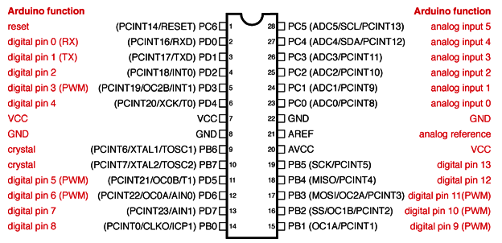

**Fig 4.2:** Atmega 328P pin diagram

* Each of the 14 digital pins on the uno can be used as an input or output, using pinmode(), digitalwrite (), and digitalread() functions. They operate at 5 volts. Each pin can provide or receive 20 ma as recommended operating condition and has an internal pull-up resistor (disconnected by default) of 20-50k ohm. A maximum of 40ma is the value that must not be exceeded on any i/o pin to avoid permanent damage to the Micro-controller.
* In addition, some pins have specialized functions:
* Serial: 0 (Rx) and 1 (Tx). Used to receive (Rx) and transmit (Tx) TTL serial data. These pins are connected to the corresponding pins of the atmega8u2 USB -to- TTL serial chip.
* External interrupts: 2 and 3. These pins can be configured to trigger an interrupt on a low value, a rising or falling edge, or a change in value. See the attach interrupt() function for details.
* PWM: 3, 5, 6, 9, 10, and 11. Provide 8-bit PWM output with the analog write() function.
* SPI: 10 (SS), 11 (MOSI), 12 (MISO), 13 (SCK). These pins support spi communication using the spi library.
* Led: 13. There is a built-in led driven by digital pin 13. When the pin is high value, the led is on, when the pin is low, it's off.
* TWI: A4 or SDA pin and A5 or SCL pin. Support TWI communication using the wire library.
* The UNO has 6 analog inputs, labeled a0 through a5, each of which provide 10 bits of resolution (i.e. 1024 different values). By default they measure from ground to 5 volts, though is it possible to change the upper end of their range using the Aref pin and the analog reference() function.
* There are a couple of other pins on the board:
* Aref.Reference voltage for the analog inputs. Used with analog reference().
* Reset. Bring this line low to reset the Micro-controller. Typically used to add a reset button to shields which block the one on the board.

|  |  |  |
| --- | --- | --- |
| ****Pin Category**** | ****Pin Name**** | ****Details**** |
| Power | Vin, 3.3V, 5V ,GND | **Vin:** Input voltage to Arduino when using an external power source.  **5V:** Regulated power supply used to power Micro-controller and other components on the board.  **3.3V:** 3.3V supply generated by on-board voltage regulator. Maximum current draw is 50mA.  GND: ground pins. |
| Reset | Reset | Resets the Micro-controller. |
| Analog Pins | A0 – A5 | Used to provide analog input in the range of 0-5V |
| Input/Output Pins | Digital Pins 0 - 13 | Can be used as input or output pins. |
| Serial | 0(Rx), 1(Tx) | Used to receive and transmit TTL serial data. |
| External Interrupts | 2, 3 | To trigger an interrupt. |
| PWM | 3, 5, 6, 9, 11 | Provides 8-bit PWM output. |
| SPI | 10 (SS), 11 (MOSI), 12 (MISO) and 13 (SCK) | Used for SPI communication. |
| Inbuilt LED | 13 | To turn on the inbuilt LED. |
| TWI | A4 (SDA), A5 (SCA) | Used for TWI communication. |
| AREF | AREF | To provide reference voltage for input voltage. |

**4.1.7 PIN DESCRIPTION**

**Table-4: Pin Description of Arduino**

# 4.2 WIFI IOT MODULE

**4.2.1 INTERNET OF THINGS (IOT)**

[Internet of things (IOT)](https://en.wikipedia.org/wiki/Internet_of_things), is another advance technology in IT sector, provides internet working for numerous of devices such as sensors, actuators, PLC’S and other electronic embedded smart devices and controls, and various software’s’ and provides systems network configuration and connectivity, which enables communication between these numerous devices for information exchanging.

In 1995, “thing to thing” was coined by BILL GATES. In 1999, IOT (Internet of Things) was come up by EPC global. IOT interconnects human to thing, thing to thing and human to human. The goal of IOT is bring out a huge network by combining different types connected devices. IOT targets three aspects Communication, automation, cost saving in a system. IOT empowers people to carry out routine activities using internet and thus saves time and cost making them more productive. IOT enables the objects to be sensed and/or controlled remotely across existing network model. IOT in environmental monitoring helps to know about the air and water quality, temperature and conditions of the soil, and also monitor the intrusion of animals in to the field. IOT can also play a significant role in precision farming to enhance the productivity of the farm.

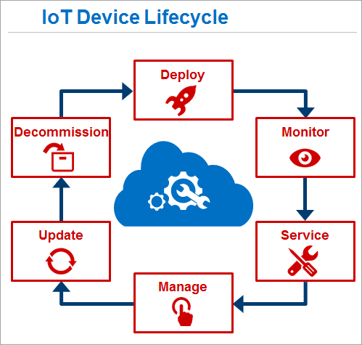

**Fig 4.03:** IOT Device Life Cycle

Through interconnection of various devices and managing of The **internet of things** (**IoT**) is the network of physical devices, vehicles, buildings and other items [embedded](https://en.wikipedia.org/wiki/Embedded_system)with [electronics](https://en.wikipedia.org/wiki/Electronics), software, sensors, actuators, and [network connectivity](https://en.wikipedia.org/wiki/Internet_access) that enable these objects to collect and exchange data. In 2013 the Global Standards Initiative on Internet of Things (IOT - GSI) defined the IOT as "the infrastructure of the information society. The IOT allows objects to be sensed and controlled remotely across existing network infrastructure, creating opportunities for more direct integration of the physical world into computer-based systems, and resulting in improved efficiency, accuracy and economic benefit.

When IOT is augmented with sensors and actuators, the technology becomes an instance of the more general class of [cyber-physical systems](https://en.wikipedia.org/wiki/Cyber-physical_system), which also encompasses technologies such as [smart grids](https://en.wikipedia.org/wiki/Smart_grid), [smart homes](https://en.wikipedia.org/wiki/Smart_home), [intelligent transportation](https://en.wikipedia.org/wiki/Intelligent_transportation) and [smart cities](https://en.wikipedia.org/wiki/Smart_city). Each thing is uniquely identifiable through its embedded computing system but is able to interoperate within the existing [Internet](https://en.wikipedia.org/wiki/Internet) infrastructure. Experts estimate that the IOT will consist of almost 50 billion objects by 2020.

IOT is a system defines an environment that encompasses numerous of objects; sensors that connected with these objects are accessible over the Internet through employing of various

Networks connections, such wired or wireless. IOT can be able to carry information from various embedded sensors attached with the physical World, human and any inanimate object, and then transmit them to a system for further analyses. In early future, IOT will be able to connect almost components or parts of industrial infrastructures, smart medical Tele - Monitoring systems, and smart transportation systems and will provide the information sharing facilities in order to make systems and peoples always updated.

**4.2.2 DESCRIPTION:**

* These modules include 1MB (8Mbit) of flash memory, twice the size of the older blue colored ESP-01 module.
* The ESP8266 Serial/UART to WiFi module is a great way to connect your Arduino or other Micro-Controller projects to a WiFi network.
* Create your next internet of things (IOT) project with affordable network connectivity by implementing this module into your design.
* The module has the ability to run independent of a host controller.
* The eight pin header includes two GPIO pins that allow for direct connection of the module to sensors, peripherals, or host controller .
* Check out our ESP8266 breadboard adapter to use your ESP8266 module with a breadboard.
* The ESP8266 has 3.6V tolerant I/Os so you will need a logic level converter to connect it with higher voltage devices such as Arduino.
* The ESP8266 requires 3.3V power so you may need a 3.3V voltage regulator to provide the correct voltage, depending on your setup.

**4.2.3 PRODUCT CONTENTS:**

* 1 — ESP8266 ESP-01 WiFi Module with baud rate set at 115200 bps.
* 1 (per order) — Addicore ESP8266 info card (includes pinout diagram.

**4.2.4 FEATURES OF WIFI IOT MODULE ESP8266:**

* Low cost, compact and powerful Wi-Fi Module.
* Power Supply: +3.3V only.
* Current Consumption: 100mA.
* I/O Voltage:  3.6V (max).
* I/O source current: 12mA (max).
* Built-in low power 32-bit MCU @ 80MHz.
* 512kB Flash Memory.
* Can be used as Station or Access Point or both combined.
* Supports Deep sleep (<10uA).
* Supports serial communication hence compatible with many development platform like Arduino.
* Can be programmed using Arduino IDE or AT-commands or Lua Script.

In this project, WIFI IOT module is just like a wireless connection between the Arduino micro-controller and the mobile device, which is connected by the IP address of the IOT module. ESP8266 WIFI module enables internet connectivity to mobile application. It uses TCP/IP communication protocol to connect with farmer.

**4.2.5 SPECIFICATIONS:**

* 802.11 b/g/n,
* Serial/UART baud rate: 115200 bps.
* Integrated TCP/IP protocol stack.
* Input power: 3.3V (see "Recommended Accessories" below for 3.3V power options).
* I/O voltage tolerance: 3.6V Max (see "Recommended Accessories" below for level converters to connect to higher voltage devices (i.e. Arduino) ).
* Regular operation current draw: ~70mA.
* Peak operating current draw: ~300mA.
* Power down leakage current: <10µA.
* +19.5dBm output in 802.11b mode.
* Flash Memory Size: 1MB (8Mbit).
* Module's dimensions: 24.75mm x 14.5mm (0.974" x 0.571").

### 4.2.6 USE OF IOT MODULE ESP8266 IN THIS PROJECT: In this project we are using IOT Module for connecting the system with internet and android mobile for online communication between our system and android mobile. By this user need not check system always user will get information through TCP/IP client.

### 4.2.7 WHY IOT MODULE ESP8266 ?

* Inexpensive. , it is cheap.
* More compatible development environments.
* Flexible Design and Enhanced Function.
* Abundant Learning Resources.
* Convenient Application Development.
* Incentive program.
* Active maker community.

**4.2.8 Working principle :**

The **ESP8266 WiFi Module** is a self contained SOC with integrated TCP/IP protocol stack that can give any microcontroller access to your **WiFi** network. The **ESP8266** is capable of either hosting an application or offloading all **WiFi** networking functions from another application processor.

ESP8266 wifi module enables internet connectivity to embedded applications. It uses TCP/UDP communication protocol to connect with server/client.

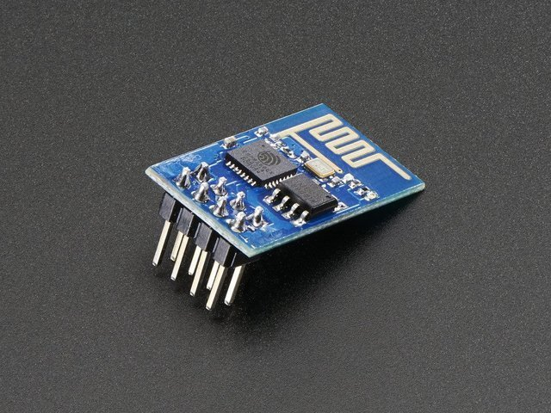

**Fig4.4:** Front view of WIFI Module

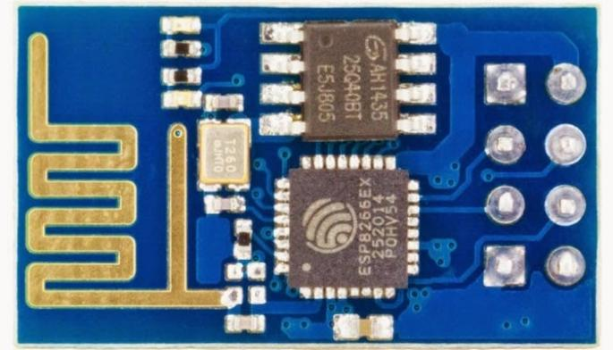

**Fig4.5:** Rear View of WIFI Module

# 4.2.9 PIN DIAGRAM:

**Table5:** Pin diagram of wifi iot module

|  |  |  |  |  |
| --- | --- | --- | --- | --- |
| **Pin Number** | **Pin Name** | **Alternate Name** | **Normally used for** | **Alternate purpose** |
| 1 | **Ground** | - | Connected to the ground of the circuit | - |
| 2 | **TX** | GPIO – 1 | Connected to Rx pin of programmer/uC  to upload program | Can act as a General purpose Input/output pin when not used as TX |
| 3 | **GPIO-2** | - | General purpose Input/output pin | - |
| 4 | **CH\_EN** | - | Chip Enable – Active high | - |
| 5 | **GPIO - 0** | Flash | General purpose Input/output pin | Takes module into serial programming when held low during start up |
| 6 | **Reset** | - | Resets the module | - |
| 7 | **RX** | GPIO - 3 | General purpose Input/output pin | Can act as a General purpose Input/output pin when not used as RX |
| 8 | **Vcc** | - | Connect to +3.3V only |  |

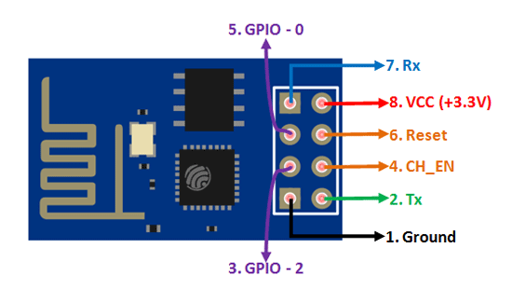

**Fig 4.6:**Pin diagram of ESP8266

**4.2.10 CONNECTING THE HARDWARE TO OUR ESP8266:**We can either use a USB-to-TTL converter or use an Arduino to program the ESP8266. Here are three methods you can follow to upload the code to ESP8266 — select the one that suits you best. Refer to the following diagrams for each and set up the hardware accordingly.

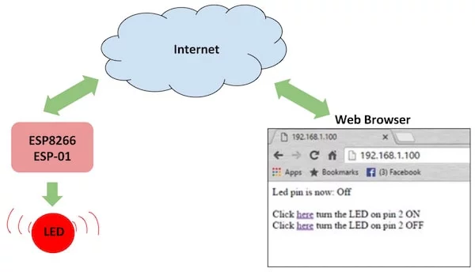

**Fig4.7:**ESP8266 sending data to web page

### **4.2.11 ESP8266-01 BOOT OPTION:**

|  |  |  |  |
| --- | --- | --- | --- |
| **GPIO – 0** | **GPIO – 2** | **Mode** | **Used For** |
| High | High | Flash Mode | Run the program that is already uploaded to the module. |
| Low | High | UART Mode | Programming mode- to program using Arduino or any serial communication. |

# Table6: ESP8266-01 BOOT OPTION

**4.2.12 INTERFACING DIAGRAM OF WIFI IOT MODULE:**

**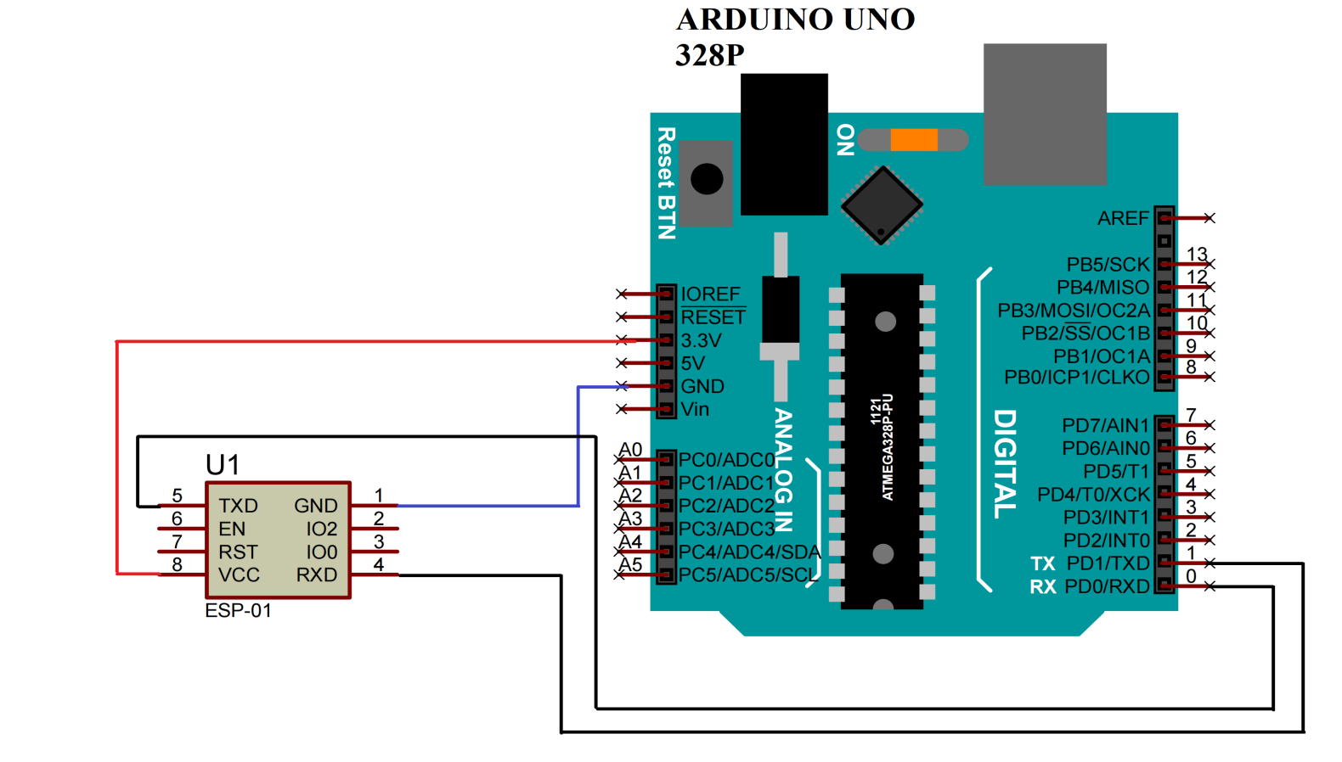**

**Fig4.8:** Interfacing Diagram

* 3.3V and ground pins of Arduino is connected to VCC and ground pins of WIFI IOT Module.
* Rx and Tx pins of WIFI IOT Module are connected to Tx and Rx pins of Arduino respectively.

**4.3 POWER SUPPLY:**

The power supply section is the section which provide +5V for the components to work. IC LM7805 is used for providing a constant power of +5V.

The ac voltage, typically 220V, is connected to a transformer, which steps down that ac voltage down to the level of the desired dc output. A diode rectifier then provides a full-wave rectified voltage that is initially filtered by a simple capacitor filter to produce a dc voltage. This resulting dc voltage usually has some ripple or ac voltage variation.

A regulator circuit removes the ripples and also retains the same dc value even if the input dc voltage varies, or the load connected to the output dc voltage changes. This voltage regulation is usually obtained using one of the popular voltage regulator IC units.

**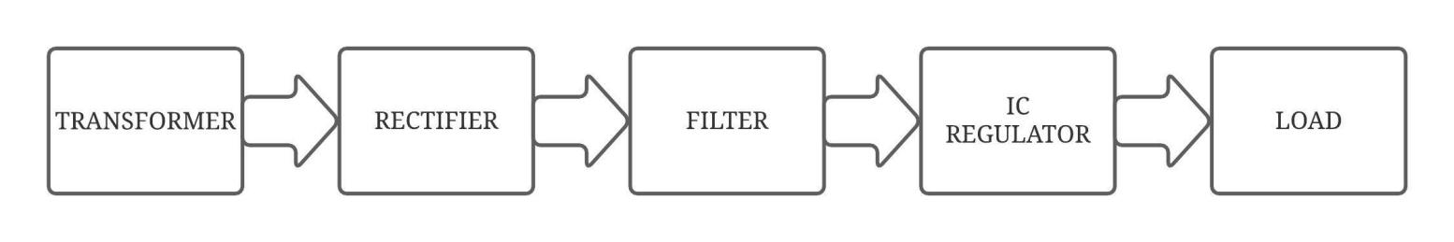**

**Fig 4.9:** Block Diagram Of Power Supply

**4.3.1 TRANSFORMER:**

Transformers convert AC electricity from one voltage to another with little loss of power. Transformers work only with AC and this is one of the reasons why mains electricity is AC.

Step-up transformers increase voltage, step-down transformers reduce voltage. Most power supplies use a step-down transformer to reduce the dangerously high mains voltage (230V in India) to a safer low voltage.

The input coil is called the primary and the output coil is called the secondary. There is no electrical connection between the two coils; instead they are linked by an alternating magnetic field created in the soft-iron core of the transformer. Transformers waste very little power so the power out is (almost) equal to the power in. Note that as voltage is stepped down current is stepped up.

The transformer will step down the power supply voltage (0-230V) to (0- 6V) level. Then the secondary of the potential transformer will be connected to the bridge rectifier, which is constructed with the help of PN junction diodes. The advantages of using bridge rectifier are it will give peak voltage output as DC.

**4.3.2 RECTIFIER:**

There are several ways of connecting diodes to make a rectifier to convert AC to DC. The bridge rectifier is the most important and it produces full-wave varying DC. A full-wave rectifier can also be made from just two diodes if a centre-tap transformer is used, but this method is rarely used now that diodes are cheaper. A single diode can be used as a rectifier but it only uses the positive (+) parts of the AC wave to produce half-wave varying DC

**4.3.3 BRIDGE RECTIFIER:**

When four diodes are connected as shown in figure, the circuit is called as bridge rectifier. The input to the circuit is applied to the diagonally opposite corners of the network, and the output is taken from the remaining two corners. Let us assume that the transformer is working properly and there is a positive potential, at point A and a negative potential at point B. the positive potential at point A will forward bias D3 and reverse bias D4.

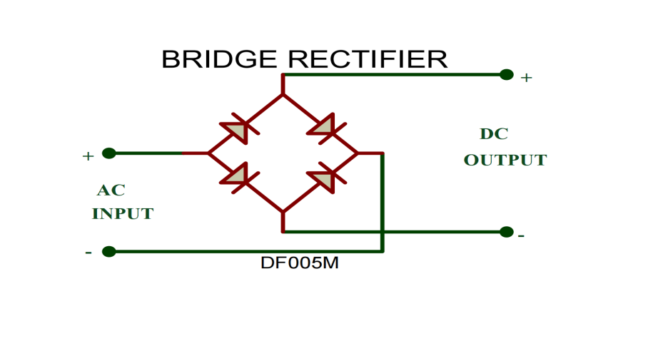

**Fig 4.10:**Bridge Rectifier

The negative potential at point B will forward bias D1 and reverse D2. At this time D3 and D1 are forward biased and will allow current flow to pass through them; D4 and D2 are reverse biased and will block current flow.

One advantage of a bridge rectifier over a conventional full-wave rectifier is that with a given transformer the bridge rectifier produces a voltage output that is nearly twice that of the conventional full-wave circuit.

i. The main advantage of this bridge circuit is that it does not require a special centre tapped transformer, thereby reducing its size and cost.

ii. The single secondary winding is connected to one side of the diode bridge network and the load to the other side as shown below.

iii. The result is still a pulsating direct current but with double the frequency.

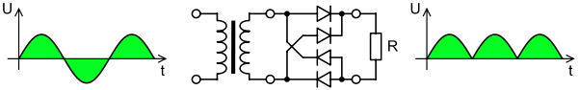

**Fig 4.11:** Output Waveform Of DC

**SMOOTHING:**

Smoothing is performed by a large value electrolytic capacitor connected across the DC supply to act as a reservoir, supplying current to the output when the varying DC voltage from the rectifier is falling. The capacitor charges quickly near the peak of the varying DC, and then discharges as it supplies current to the output.

**4.3.4 Voltage Regulators:**

Voltage regulators comprise a class of widely used ICs. Regulator IC units contain the circuitry for reference source, comparator amplifier, control device, and overload protection all in a single IC. IC units provide regulation of either a fixed positive voltage, a fixed negative voltage, or an adjustably set voltage. The regulators can be selected for operation with load currents from hundreds of milli amperes to tens of amperes, corresponding to power ratings from milli watts to

tens of watts.

A fixed three-terminal voltage regulator has an unregulated dc input voltage, Vi, applied to one input terminal, a regulated dc output voltage, Vo, from a second terminal, with the third terminal connected to ground.

The series 78 regulators provide fixed positive regulated voltages from 5 to 24 volts. Similarly, the series 79 regulators provide fixed negative regulated voltages from 5 to 24 volts. Voltage regulator ICs are available with fixed (typically 5, 12 and 15V) or variable output voltages. They are also rated by the maximum current they can pass. Negative voltage regulators are available, mainly for use in dual supplies. Most regulators include some automatic protection from excessive current ('overload protection') and overheating ('thermal protection').

Many of the fixed voltage regulator ICs has 3 leads and look like power transistors, such as the 7805 +5V 1Amp regulator. They include a hole for attaching a heat sink if necessary.

**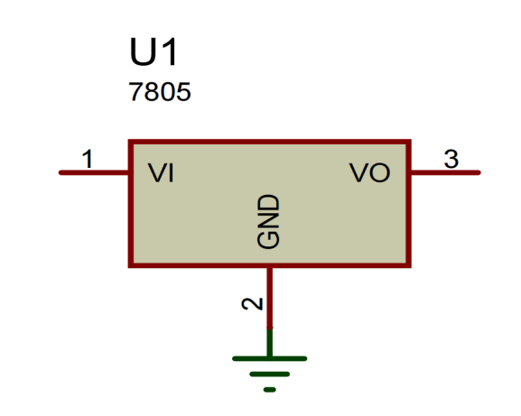**

**Fig 4.12:** Regulator

**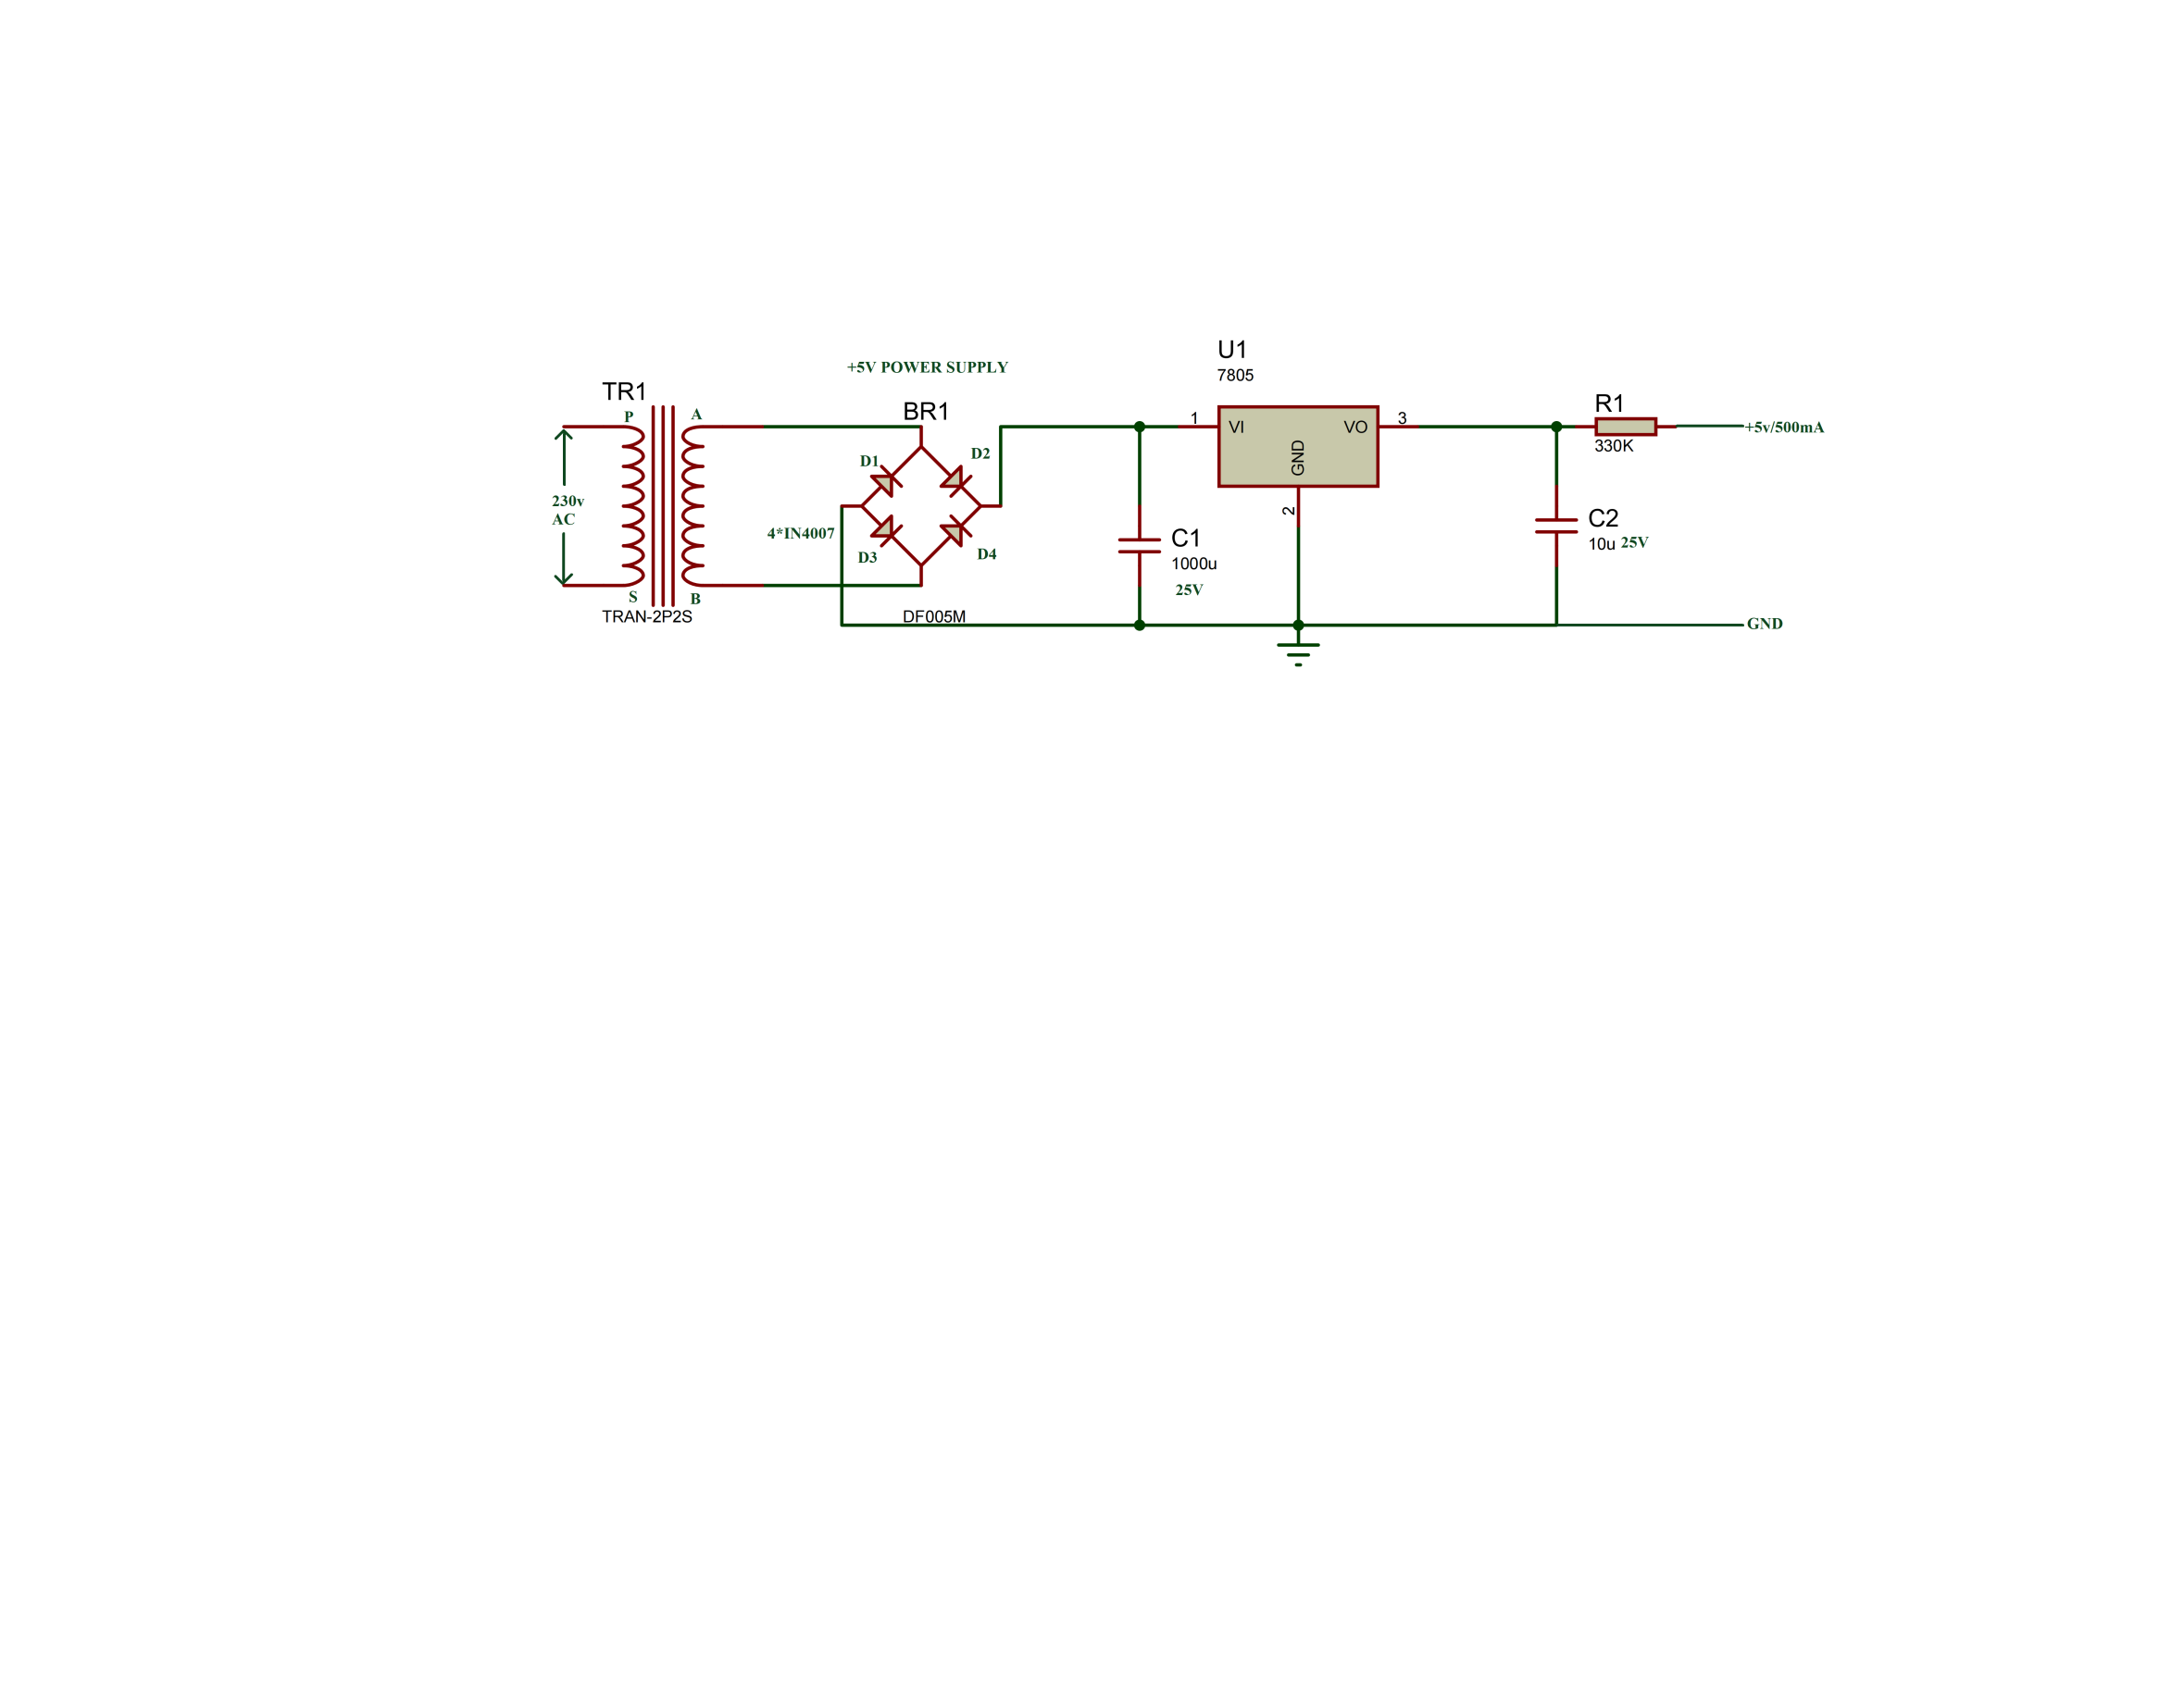**

**Fig 4.13:**Circuit Diagram Of Power Supply

**4.3.5 FEATURES:**

* Input voltage: 7v to 25v
* Output voltage range: 4.8 v to 5.2v
* Typical output voltage: 5v
* Maximum output current: 1.5A

**4.3.6 WORKING PRINCIPLE:**

* The AC voltage is first stepped down by a transformer to satisfy the voltage requirements of the power supply load. Once the voltage is stepped down, a rectifier will then turn the sinusoidal AC waveform into a set of positive troughs and crests.
* At this point, there’s still an oscillation in the AC waveform, so a filter is used to smooth out the AC voltage into a usable DC supply.
* Now that the AC has been converted into usable DC, some power supplies will further remove any ripples in the waveform with the help of a regulator. This regulator will provide a steady DC output regardless of changes that happen to the input AC voltage.
* That’s the process at a glance. Regardless of what power supply you look at, it will always have at least three primary components – a transformer, rectifier, and filter. Regulators may or may not be used depending on if the power supply is unregulated or regulated (more on this later).

**4.4 LIQUID CRYSTAL DISPLAY (LCD):**

LCD (Liquid Crystal Display) screen is an electronic display module and find a wide range of applications. A 16x2 LCD display is very basic module and is very commonly used in various devices and circuits. These modules are preferred over [seven segments](http://www.engineersgarage.com/content/seven-segment-display) and other multi segment [LED](http://www.engineersgarage.com/content/led)s. The reasons being: LCDs are economical; easily programmable; have no limitation of displaying special & even [custom characters](http://www.engineersgarage.com/microcontroller/8051projects/create-custom-characters-LCD-AT89C51) (unlike in seven segments), [animations](http://www.engineersgarage.com/microcontroller/8051projects/display-custom-animations-LCD-AT89C51) and so on.

A **16x2 LCD** means it can display 16 characters per line and there are 2 such lines. In this LCD each character is displayed in 5x7 pixel matrix. This LCD has two registers, namely, Command and Data.

The command register stores the command instructions given to the LCD. A command is an instruction given to LCD to do a predefined task like initializing it, clearing its screen, setting the cursor position, controlling display etc. The data register stores the data to be displayed on the LCD. The data is the ASCII value of the character to be displayed on the LCD.

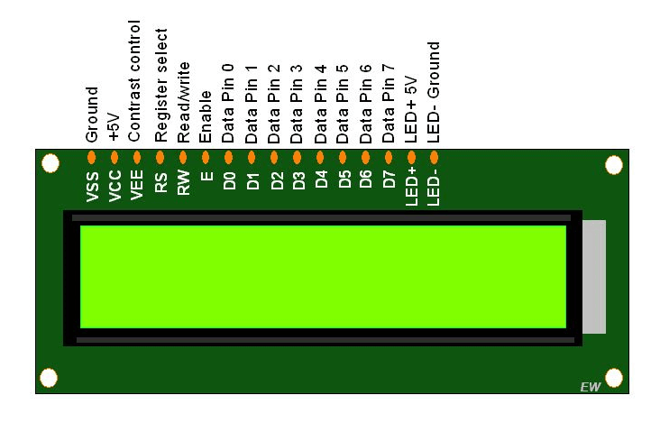

**Fig 4.14:** LCD

Since LCD screens do not use phosphors, they rarely suffer image burn-in when a static image is displayed on a screen for a long time, e.g., the table frame for an airline flight schedule on an indoor sign. LCDs are, however, susceptible to image persistence.[3] The LCD screen is more energy-efficient and can be disposed of more safely than a CRT can. Its low electrical power consumption enables it to be used in battery-powered electronic equipment more efficiently than a CRT can be. By 2008, annual sales of televisions with LCD screens exceeded sales of CRT units worldwide, and the CRT became obsolete for most purposes.

**4.4.1 SPECIFICATIONS OF LCD:**

* **Operating Voltage** is 4.7V to 5.3V
* **Resolution:** The resolution of an LCD is expressed by the number of columns and rows of pixels (e.g., 1024×768). Each pixel is usually composed 3 sub-pixels, a red, a green, and a blue one. This had been one of the few features of LCD performance that remained uniform among different designs. However, there are newer designs that share sub-pixels among pixels and add Quattron which attempt to efficiently increase the perceived resolution of a display without increasing the actual resolution, to mixed results.
* **Spatial performance:** For a computer monitor or some other display that is being viewed from a very close distance, resolution is often expressed in terms of dot pitch or pixels per inch, which is consistent with the printing industry. Display density varies per application, with televisions generally having a low density for long-distance viewing and portable devices having a high density for close- range detail. The Viewing Angle of an LCD may be important depending on the display and its usage, the limitations of certain display technologies mean the display only displays accurately at certain angles.
* **Temporal performance:** the temporal resolution of an LCD is how well it can display changing images, or the accuracy and the number of times per second the display draws the data it is being given. LCD pixels do not flash on/off between frames, so LCD monitors exhibit no refresh-induced flicker no matter how low the refresh rate. But a lower refresh rate can mean visual artefacts like ghosting or smearing, especially with fast moving images. Individual pixel response time is also important, as all displays have some inherent latency in displaying an image which can be large enough to create visual artifacts if the displayed image changes rapidly.
* **Color performance**: There are multiple terms to describe different aspects of color performance of a display. Color gamut is the range of colors that can be displayed, and color depth, which is the fineness with which the color range is divided. Color gamut is a relatively straight forward feature, but it is rarely discussed in marketing materials except at the professional level. Having a color range that exceeds the content being shown on the screen has no benefits, so displays are only made to perform within or below the range of a certain specification. There are additional aspects to LCD color and color management, such as white point and gamma correction, which describe what color white is and how the other colors are displayed relative to white.
* **Brightness and contrast ratio:** Contrast ratio is the ratio of the brightness of a full-on pixel to a full- off pixel. The LCD itself is only a light valve and does not generate light; the light comes from a backlight that is either fluorescent or a set of LEDs. Brightness is usually stated as the maximum light output of the LCD, which can vary greatly based on the transparency of the LCD and the brightness of the backlight. In general, brighter is better[citation needed], but there is always a trade-off between brightness and power consumption.

**4.4.2 FEATURES OF LCD:**

**Viewing Angle:**

* When you look at an LCD monitor from an angle, the image can look dimmer or even disappear. Colors can also be misrepresented. To compensate for this problem, LCD monitor makers have designed wider viewing angles. (Do not confuse this with a widescreen display, which means the display is physically wider.) Manufacturers give a measure of viewing angle in degrees (a greater number of degrees is better). In general, look for between 120 and 170 degrees. Because manufacturers measure viewing angles differently, the best way to evaluate it is to test the display yourself. Check the angle from the top and bottom as well as the sides, bearing in mind how you will typically use the display.

**Brightness or Luminance:**

* This is a measurement of the amount of light the LCD monitor produces. It is given in nits or one candelas per square meter (cd/m2). One nit is equal to one cd/m2. Typical brightness ratings range from 250 to 350 cd/m2 for monitors that perform general-purpose tasks. For displaying movies, a brighter luminance rating such as 500 cd/m2 is desirable.

**Contrast Ratio:**

* The contrast ratio rates the degree of difference of an LCD monitor's ability to produce bright whites and the dark blacks. The figure is usually expressed as a ratio, for example, 500:1. Typically, contrast ratios range from 450:1 to 600:1, and they can be rated as high as 1000:1. Ratios more than 600:1, however, provide little improvement over lower ratios.

**Response Rate:**

* The response rate indicates how fast the monitor's pixels can change colors. Faster is better because it reduces the ghosting effect when an image moves, leaving a faint trial in such applications as videos or games.

**Adjustability:**

* Unlike CRT monitors, LCD monitors have much more flexibility for positioning the screen the way you want it. LCD monitors can swivel, tilt up and down, and even rotate from landscape (with the horizontal plane longer than the vertical plane) to portrait mode (with the vertical plane longer than the horizontal plane). In addition, because they are lightweight and thin, most LCD monitors have built-in brackets for wall or arm mounting.

Besides the basic features, some LCD monitors have other conveniences such as integrated speakers, built-in Universal Serial Bus (USB) ports and anti-theft locks.

**4.4.3 PIN CONFIGURATION TABLE FOR A 16X2 LCD CHARACTER DISPLAY:**

|  |  |  |
| --- | --- | --- |
| **Pin Number** | **Symbol** | **Function** |
| **1** | Vss | Ground Terminal |
| **2** | Vcc | Positive Supply |
| **3** | Vdd | Contrast adjustment |
| **4** | RS | Register Select; 0→Instruction Register, 1→Data Register |
| **5** | R/W | Read/write Signal; 1→Read, 0→ Write |
| **6** | E | Enable; Falling edge |
| **7** | DB0 | Bi-directional data bus, data transfer is performed once, thru DB0 to DB7, in the case of interface data length is 8-bits; and twice, through DB4 to DB7 in the case of interface data length is 4-bits. Upper four bits first then lower four bits. |
| **8** | DB1 |
| **9** | DB2 |
| **10** | DB3 |
| **11** | DB4 |
| **12** | DB5 |
| **13** | DB6 |
| **14** | DB7 |
| **15** | LED-(K) | Back light LED cathode terminal |
| **16** | LED+(A) | Back Light LED anode terminal |

**Table7:** Pin Description of LCD

* Pin1 (Ground/Source Pin): This is a GND pin of display, used to connect the GND terminal of the micro-controller unit or power source.
* Pin2 (VCC/Source Pin): This is the voltage supply pin of the display, used to connect the
* supply pin of the power source.Pin3 (V0/VEE/Control Pin): This pin regulates the difference of the display, used to connect a changeable POT that can supply 0 to 5V.
* Pin4 (Register Select/Control Pin): This pin toggles among the command or data register, used to connect a microcontroller unit pin and obtains either 0 or 1(0 = data mode, and 1 =command mode).
* Pin5 (Read/Write/Control Pin): This pin toggles the display among the read or writes operation, and it is connected to a microcontroller unit pin to get either 0 or 1 (0 = Write Operation, and 1 = Read Operation).
* Pin 6 (Enable/Control Pin): This pin should be held high to execute the Read/Write process, and it is connected to the microcontroller unit & constantly held high.
* Pins 7-14 (Data Pins): These pins are used to send data to the display. These pins are connected in two- wire modes like 4-wire mode and 8-wire mode. In 4-wire mode, only four pins are connected to the Micro controller unit like 0 to 3, whereas in 8-wire mode, 8-pins are connected to Micro controller units like 0 to 7.
* Pin15 (+ve pin of the LED): This pin is connected to +5V
* Pin 16 (-ve pin of the LED): This pin is connected to GND

### 4.4.4 PIN DIAGRAM:

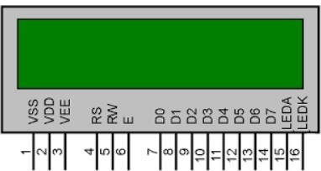

**Fig4.15:** Pin diagram of LCD

**4.4.5 WORKING PRINCIPLE OF LCD:**

A liquid crystal display (LCD) has liquid crystal material sandwiched between two sheets of glass. Without any voltage applied between transparent electrodes, liquid crystal molecules are aligned in parallel with the glass surface. When voltage is applied, they change their direction and they turn vertical to the glass surface. They vary in optical characteristics, depending on their orientation. Therefore, the quantity of light transmission can be controlled by combining the motion of liquid crystal molecules and the direction of polarization of two polarizing plates attached to the both outer sides of the glass sheets. LCDs utilize these characteristics to display images.

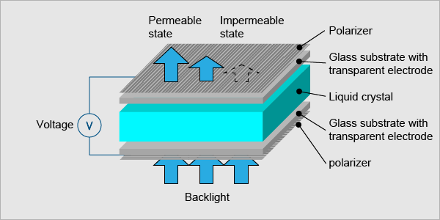

**Fig 4.16:** Working Principle of LCD

**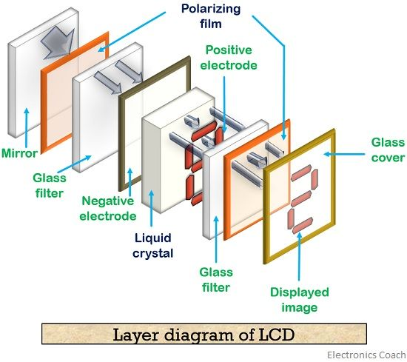**

**Fig 4.17:** Layers of LCD

### 4.4.6 USE OF THIS LCD IN THIS PROJECT:

In this project the LCD is used to display the output whether the leaf is healthy or leaf is affected.

This LCD is additional component in this project to show the output results of the project.And it is integrated in this system.

**4.4.7 WHY ONLY LCD?**

**Energy Efficient:**

LCD’s are known for their energy-efficient properties. They still require power to illuminate their respective pixels, but LCD’s consume less power than non-LCD devices. When compared to cathode-ray tube (CRT), for example, a typical LCD will use about 25% less power. As a result, LCDs offer cost-savings benefits in the form of cheaper utility bills. You’ll pay less in utility expenses if you choose an LCD over a non-LCD device, making it a smart investment.

**Long-Lasting**:

Another advantage of LCD’s is their ability to last for a very long time. LCD’s typically don’t last forever, but they have a longer lifespan than that of other display devices. A typical LCD may last for up to 60,000 hours. Depending on how frequently you use it, that may translate into 20 or more years of usage. CRT displays, on the other hand, have a much shorter lifespan.

## **LED Backlighting:**

LCDs support backlighting with light-emitting diode (LED). LED, in fact, is the most common type of backlighting used in their construction. To illuminate their respective pixels, LCDs need backlighting. LED backlighting has become the preferred choice among manufacturers because it’s both effective and energy efficient. The LED bulbs are placed in the back of the LCD where they illuminate the liquid pixels from behind.

**No Screen Burn-In:**

You don’t have to worry about screen burn-in with LCDs. Screen burn-in is a phenomenon that only occurs in display devices with phosphor-based pixels. Traditional CRTs fall under this category because their pixels are made of phosphor compounds. LCDs, however, use pixels made of organic material, so they don’t suffer from screen burn-in. You can leave a static image on an LCD for multiple consecutive hours without fear of it “burning” into the display.

**Supports Small and Low-Profile Sizes:**

LCD devices come in all shapes and sizes. While some of them are large, others are small with a narrow and low-profile design. Smartphones and tablets, for example, often use LCD technology. It allows for small and low-profile designs that isn’t possible with other, older display technologies.

**Data/Signals/Execution of LCD:**

Coming to data, signals and execution. LCD accepts two types of signals, one is data, and another is control. These signals are recognized by the LCD module from status of the RS pin. Now data can be read also from the LCD display, by pulling the R/W pin high. As soon as the E pin is pulsed, LCD display reads data at the falling edge of the pulse and executes it, same for the case of transmission.

         LCD display takes a time of 39-43µS to place a character or execute a command. Except for clearing display and to seek cursor to home position it takes 1.53ms to 1.64ms. Any attempt to send any data before this interval may lead to failure to read data or execution of the current data in some devices. Some devices compensate the speed by storing the incoming data to some temporary registers.

**Instruction Register (IR) and Data Register (DR):**

There are two 8-bit registers in HD44780 controller Instruction and Data register. Instruction register corresponds to the register where you send commands to LCD e.g LCD shift command, LCD clear, LCD address etc. and Data register is used for storing data which is to be displayed on LCD. when send the enable signal of the LCD is asserted, the data on the pins is latched in to the data register and data is then moved automatically to the DDRAM and hence is displayed on the LCD. Data Register is not only used for sending data to DDRAM but also for CGRAM, the address where you want to send the data, is decided by the instruction you send to LCD. We will discuss more on LCD instruction set further in this tutorial.

**Commands and Instruction set**

Only the instruction register (IR) and the data register (DR) of the LCD can be controlled by the MCU. Before starting the internal operation of the LCD, control information is temporarily stored into these registers to allow interfacing with various MCUs, which operate at different speeds, or various peripheral control devices. The internal operation of the LCD is determined by signals sent from the MCU. These signals, which include register selection signal (RS), read/write signal (R/W), and the data bus (DB0 to DB7), make up the LCD instructions (Table 3). There are four categories of instructions that:

* Designate LCD functions, such as display format, data length, etc.
* Set internal RAM addresses
* Perform data transfer with internal RAM
* Perform miscellaneous functions

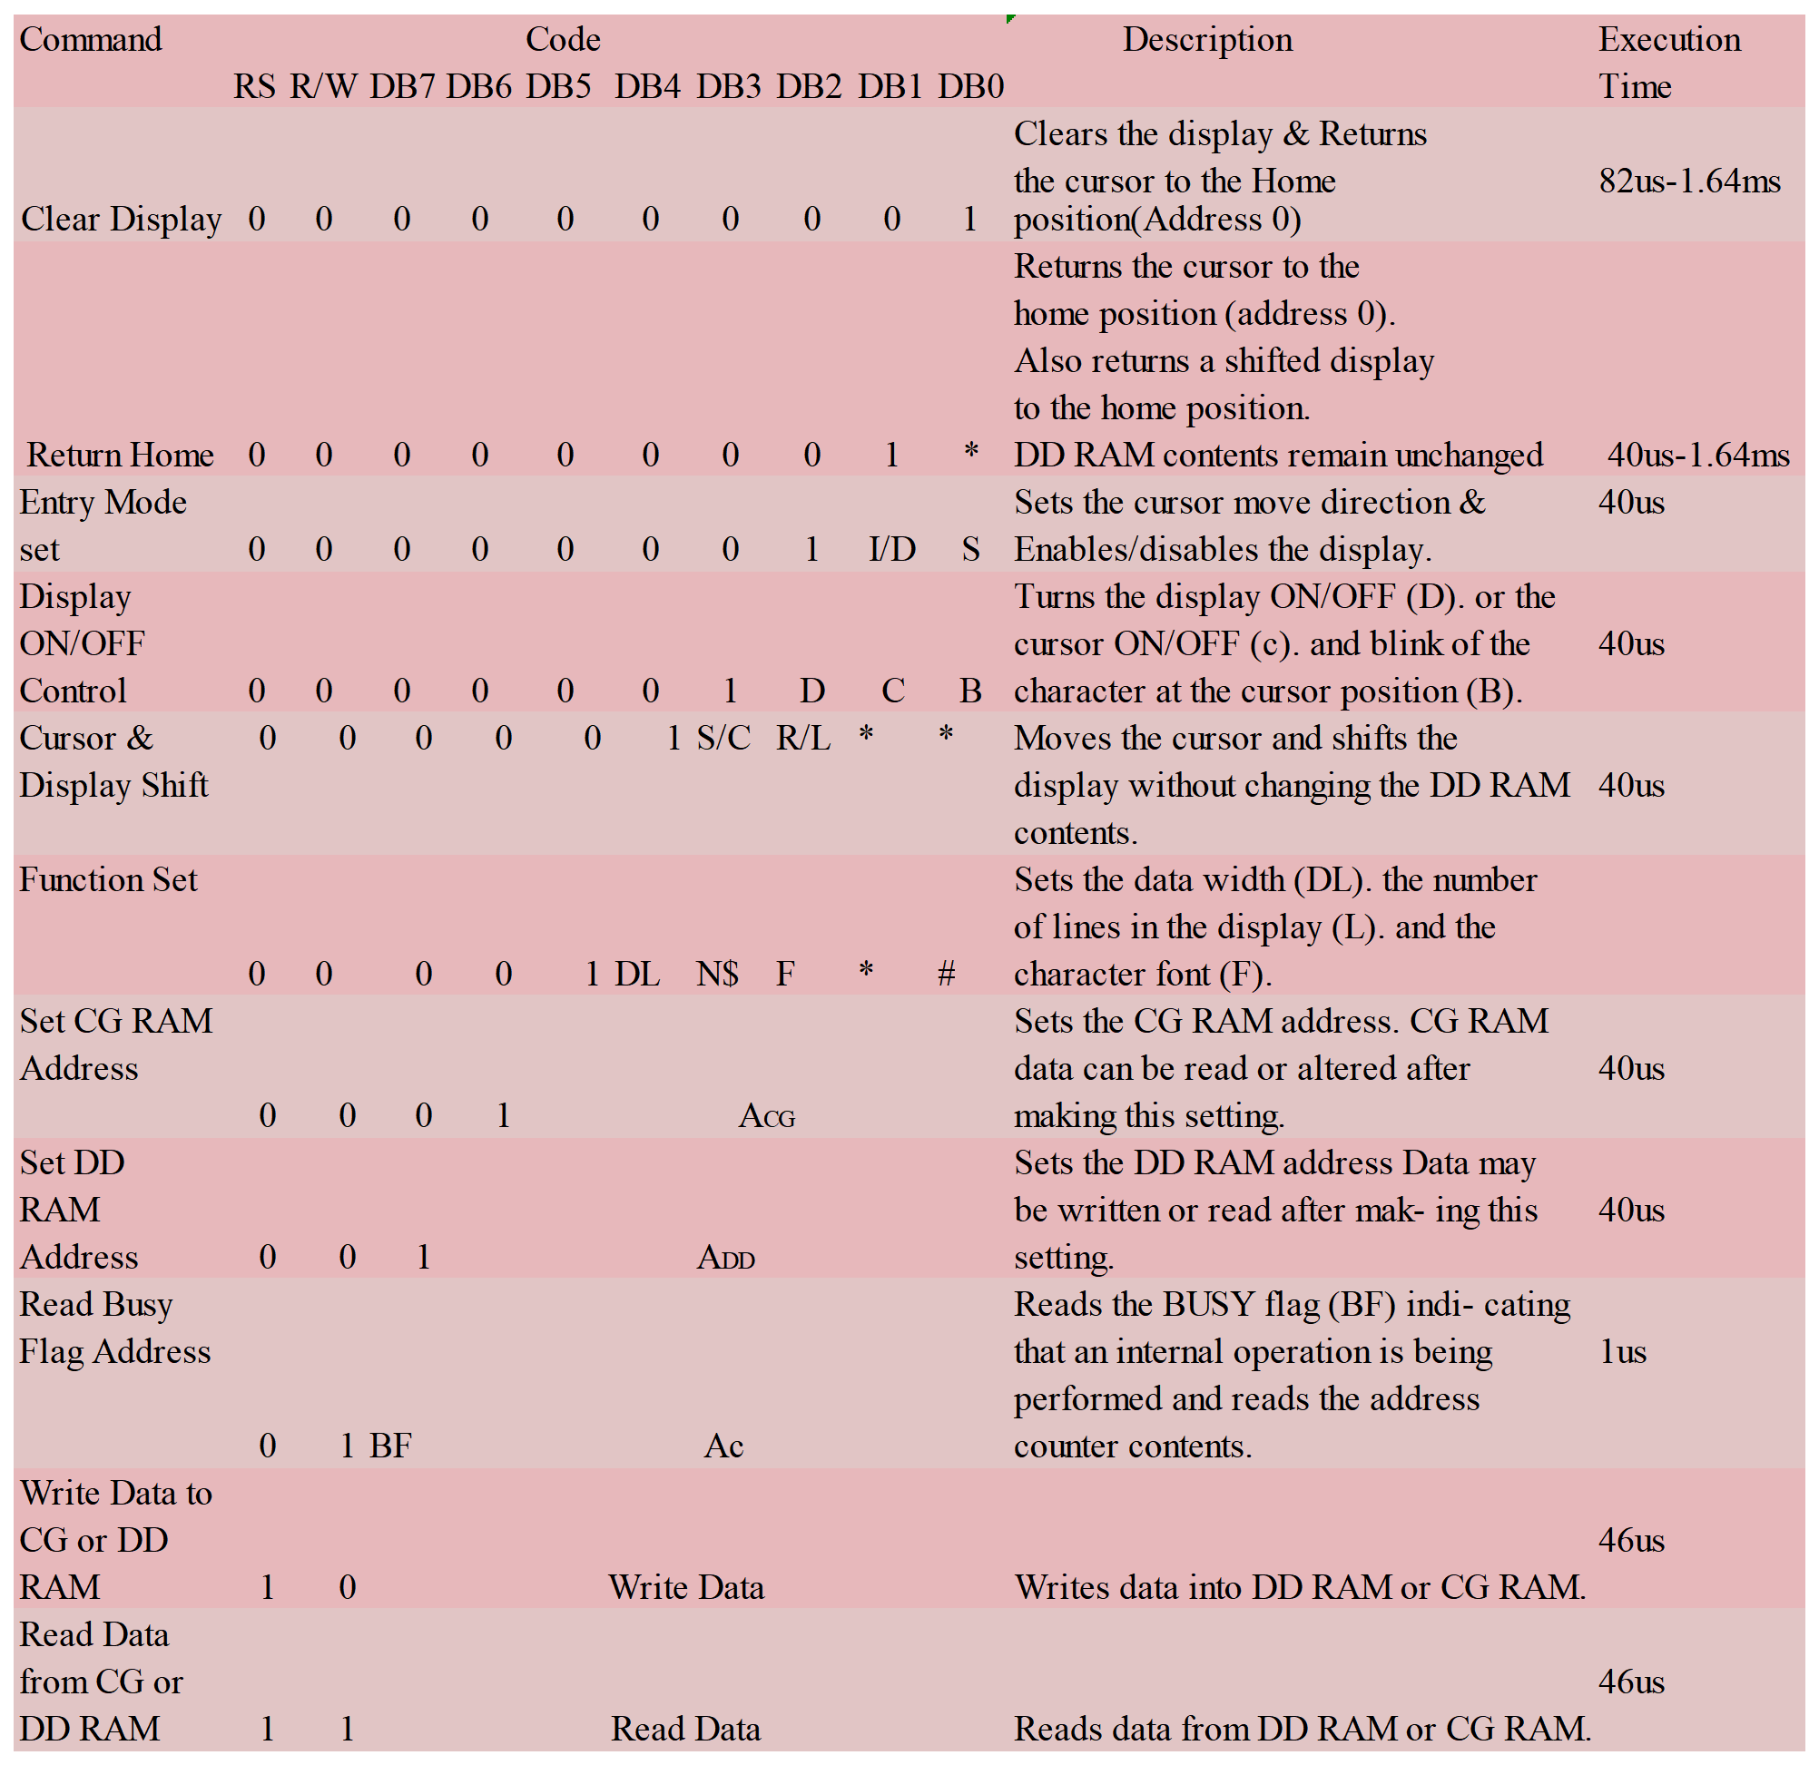

**Table 8:** LCD Command Description

**2.4.8 List of Command:**

|  |  |  |  |
| --- | --- | --- | --- |
| **No.** | **Instruction** | **Hex** | **Decimal** |
| 1 | Function Set: 8-bit, 1 Line, 5x7 Dots | 0x30 | 48 |
| 2 | Function Set: 8-bit, 2 Line, 5x7 Dots | 0x38 | 56 |
| 3 | Function Set: 4-bit, 1 Line, 5x7 Dots | 0x20 | 32 |
| 4 | Function Set: 4-bit, 2 Line, 5x7 Dots | 0x28 | 40 |
| 5 | Entry Mode | 0x06 | 6 |
| 6 | Display off Cursor off (clearing display without clearing DDRAM content) | 0x08 | 8 |
| 7 | Display on Cursor on | 0x0E | 14 |
| 8 | Display on Cursor off | 0x0C | 12 |
| 9 | Display on Cursor blinking | 0x0F | 15 |
| 10 | Shift entire display left | 0x18 | 24 |
| 12 | Shift entire display right | 0x1C | 30 |
| 13 | Move cursor left by one character | 0x10 | 16 |
| 14 | Move cursor right by one character | 0x14 | 20 |
| 15 | Clear Display (also clear DDRAM content) | 0x01 | 1 |
| 16 | Set DDRAM address or courser position on display | 0x80+add\* | 128+add\* |
| 17 | Set CGRAM address or set pointer to CGRAM location | 0x40+add\*\* | 64+add\*\* |

**Table 9 :** Frequently Used Commands and Instructions for LCD

**4.4.9 INTERFACING OF LCD WITH ARDUINO:**

**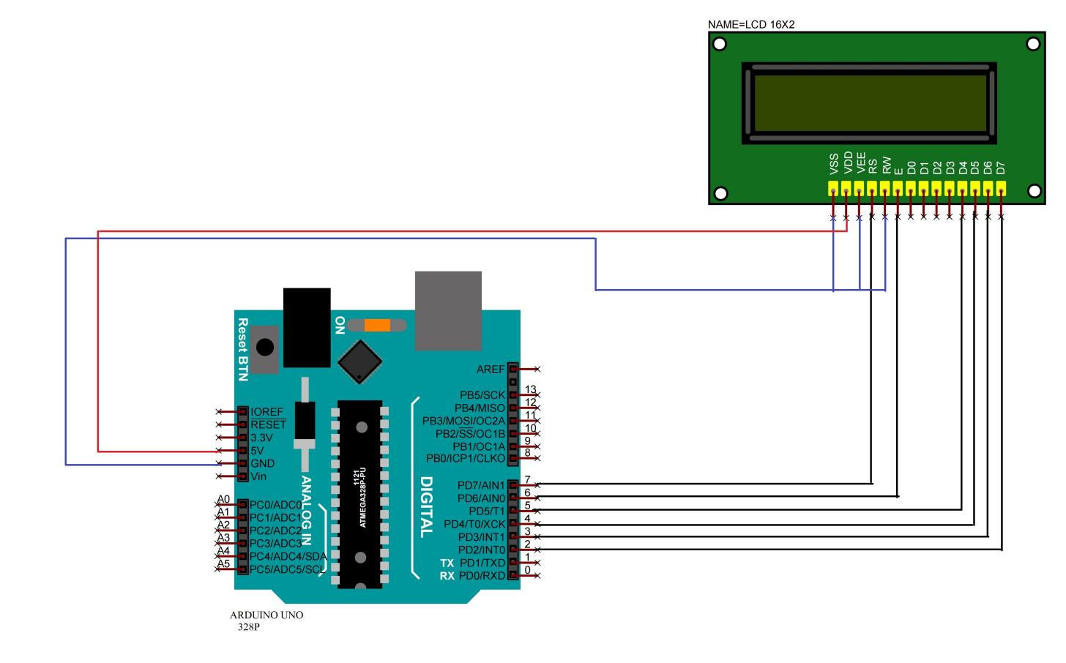**

**Fig 4.18:** Interfacing Diagram

**Liquid crystal displays interfacing with Controller**

* The LCD standard requires 3 control lines and 8 I/O lines for the data bus.
* 5V output pin of Arduino is connected to VDD pin of LCD.
* LCD’s Bi-directional data bus D7-D4 pins are connected with digital pins (2-5) of Arduino Uno.
* Register select, Enable pins are connected to digital pins (7,6) of Arduino Uno respectively.
* VDD, RW and VEE pins of LCD are connected to ground.

**4.5 GSM (GLOBAL SYSTEM FOR MOBILE):**

The Global System for Mobile Communications (GSM) is a standard developed by the European Telecommunications Standards Institute (ETSI) to describe the protocols for second-generation (2G) digital cellular networks used by mobile devices such as mobile phones and tablets. It was first deployed in Finland in December 1991.By the mid-2010s, it became a global standard for mobile communications achieving over 90% market share, and operating in over 193 countries and territories.

2G networks developed as a replacement for first generation (1G) analog cellular networks. The GSM standard originally described a digital, circuit-switched network optimized for full duplex voice telephony. This expanded over time to include data communications, first by circuit-switched transport, then by packet data transport via General Packet Radio Service (GPRS), and Enhanced Data Rates for GSM Evolution (EDGE).

Subsequently, the 3GPP developed third-generation (3G) UMTS standards, followed by the fourth-generation (4G) LTE Advanced and the fifth-generation 5G standards, which do not form part of the ETSI GSM standard.

"GSM" is a trade mark owned by the GSM Association.

Global System for Mobile Communications (GSM) modems are specialized types of modems that operate over subscription based wireless networks, similar to a mobile phone. A GSM modem accepts a Subscriber Identity Module (SIM) card, and basically acts like a mobile phone for a computer. Such a modem can even be a dedicated mobile phone that the computer uses for GSM network capabilities.

Traditional modems are attached to computers to allow dial-up connections to other computer systems. A GSM modem operates in a similar fashion, except that it sends and receives data through radio waves rather than a telephone line. This type of modem may be an external device connected via a Universal Serial Bus (USB) cable or a serial cable. More commonly, however, it is a small device that plugs directly into the USB port or card slot on a computer or laptop.

It is widely used mobile communication system in the world. GSM is an open and digital cellular technology used for transmitting mobile voice and data services operates at the 850MHz, 900MHz, 1800MHz and 1900MHz frequency bands.

A GSM modem is a wireless modem that works with a GSM wireless network. A wireless modem behaves like a dial-up modem. The main difference between them is that a dial-up modem sends and receives data through a fixed telephone line while a wireless modem sends and receives data through radio waves.

A GSM modem can be an external device or a PC Card / PCMCIA Card. Typically, an external GSM modem is connected to a computer through a serial cable or a USB cable. A GSM modem in the form of a PC Card / PCMCIA Card is designed for use with a laptop computer. It should be inserted into one of the PC Card / PCMCIA Card slots of a laptop computer. Like a GSM mobile phone, a GSM modem requires a SIM card from a wireless carrier in order to operate.

As mentioned in earlier sections of this SMS tutorial, computers use AT commands to control modems. Both GSM modems and dial-up modems support a common set of standard AT commands. You can use a GSM modem just like a dial-up modem.

In addition to the standard AT commands, GSM modems support an extended set of AT commands. These extended AT commands are defined in the GSM standards. With the extended AT commands, you can do things like:

* Reading, writing and deleting SMS messages.
* Sending SMS messages.
* Monitoring the signal strength.
* Monitoring the charging status and charge level of the battery.
* Reading, writing and searching phone book entries.

The number of SMS messages that can be processed by a GSM modem per minute is very low -- only about six to ten SMS messages per minute.

**4.5.1 FEATURES:**

* Improved spectrum efficiency.
* International roaming.
* Compatibility with integrated services digital network (ISDN).
* Support for new services.
* SIM phonebook management.
* Fixed dialing number (FDN).
* Real time clock with alarm management.
* High-quality speech.
* Uses encryption to make phone calls more secure.
* Short message service (SMS).

### ****4.5.2 SIM900A GSM MODULE PINOUT CONFIGURATION:****

SIM900A is a 68 terminal device as shown in pin diagram. We will describe the function of each pin below.

|  |  |  |
| --- | --- | --- |
| ****Pin Number**** | ****Pin Name**** | ****Description**** |
| 1 | PWRKEY | Voltage input for PWRKEY.  PWRKEY should be pulled low to power on or power off the system.  The user should keep pressing the key for a short time when power on or power off the system because the system need margin time in order to assert the software. |
| 2 | PWRKEY\_OUT | Connecting PWRKEY and PWRKEY\_OUT for a short time then release also can power on or power off the module. |
| 3 | DTR | Data terminal Ready  [Serial port ] |
| 4 | RI | Ring indicator  [Serial port ] |
| 5 | DCD | Data carry detect  [Serial port ] |
| 6 | DSR | Data Set Ready  [Serial port ] |
| 7 | CTS | Clear to send [Serial port ] |
| 8 | RTS | Request to send [Serial port ] |
| 9 | TXD | Transmit data [Serial port ] |
| 10 | RXD | Receive data [Serial port ] |
| 11 | DISP \_CLK | Clock for display [Display interface] |
| 12 | DISP\_DATA | Display data output [Display interface] |
| 13 | DISP \_D/C | Display data or command select [Display interface] |
| 14 | DISP \_CS | Display Enable [Display interface] |
| 15 | VDD\_EXT | 2.8V output power supply |
| 16 | NRESET | External reset input |
| 17,18,29,39,45,  46,53,54,58,59,  61,62,63,64,65 | GND | Ground |
| 19 | MIC\_P | Microphone Positive |
| 20 | MIC\_N | Microphone Negative |
| 21 | SPK\_P | Speaker Positive |
| 22 | SPK\_N | Speaker Negative |
| 23 | LINEIN\_R | Right Channel input [External line inputs are available to directly mix or multiplex externally generated analog signals such as polyphonic tones from an external melody IC or music generated by an FM tuner IC or module.] |
| 24 | LINEIN\_L | Left Channel Input |
| 25 | ADC | General purpose analog to digital converter. |
| 26 | VRTC | Current input for RTC when the battery is not supplied for the system.  Current output for backup battery when the main battery is present and the backup battery is in low voltage state. |
| 27 | DBG\_TXD | Transmit pin [Serial interface for debugging and firmware upgrade ] |
| 28 | DBG\_RXD | Receive pin [Serial interface for debugging and firmware upgrade ] |
| 30 | SIM\_VDD | Voltage supply for SIM card |
| 31 | SIM\_DATA | SIM data output |
| 32 | SIM\_CLK | SIM clock |
| 33 | SIM\_RST | SIM reset |
| 34 | SIM\_PRESENCE | SIM detect |
| 35 | PWM1 | PWM Output |
| 36 | PWM2 | PWM Output |
| 37 | SDA | Serial Data [I2C] |
| 38 | SCL | Serial Clock [I2C] |
| 40,41,42,43,44  &  47,48,49,50,51 | KBR0 to KBR4  &  KBC4 to KBC0 | Keypad interface  [ROWS & COLUMNS] |
| 52 | NETLIGHT | Indicate net status |
| 55,56,57 | VBAT | Three VBAT pins are dedicated to connect the supply voltage. The power supply of SIM900A has to be a single voltage source of VBAT= 3.4V to 4.5V. It must be able to provide sufficient current in a transmit burst which typically rises to 2A. |
| 60 | RF\_ANT | Antenna connection |
| 66 | STATUS | Indicate working status |
| 67 | GPIO 11 | General Purpose Input/output |
| 68 | GPIO 12 | General Purpose Input/output |

**Table10 :** Configuration of SIM 900A

**4.5.3 PIN DIAGRAM:**

**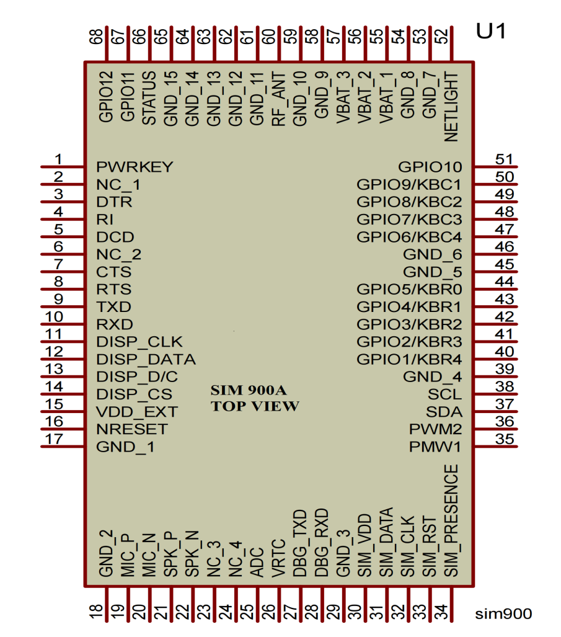**

**Fig4.19:** SIM 900A Pin Diagram

**4.5.4 SPECIFICATIONS AND CHARACTERISTICS FOR GSM:**

* **frequency band**—The frequency range specified for GSM is 1,850 to 1,990 MHz (mobile station to base station).
* **duplex distance**—The duplex distance is 80 MHz. Duplex distance is the distance between the uplink and downlink frequencies. A channel has two frequencies, 80 MHz apart.
* **channel separation**—The separation between adjacent carrier frequencies. In GSM, this is 200 kHz.
* **modulation**—Modulation is the process of sending a signal by changing the characteristics of a carrier frequency. This is done in GSM via Gaussian minimum shift keying (GMSK).
* **transmission rate**—GSM is a digital system with an over-the-air bit rate of 270 kbps.
* **access method**—GSM utilizes the time division multiple access (TDMA) concept. TDMA is a technique in which several different calls may share the same carrier. Each call is assigned a particular time slot.
* **speech coder**—GSM uses linear predictive coding (LPC). The purpose of LPC is to reduce the bit rate. The LPC provides parameters for a filter that mimics the vocal tract. The signal passes through this filter, leaving behind a residual signal. Speech is encoded at 13 kbps.

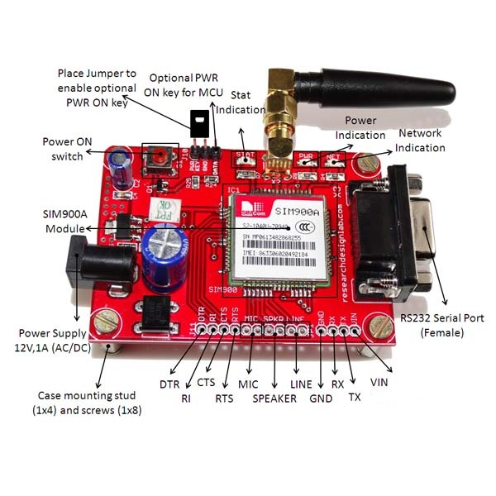

### Fig4.20: GSM Module

### 4.5.5 USE OF THIS GSM IN THIS PROJECT:

A GSM modem or GSM module is a hardware device that uses GSM mobile telephone technology to provide a data link to a remote network. From the view of the mobile phone network, they are essentially identical to an ordinary mobile phone, including the need for a SIM to identify themselves to the network

**4.5.6 WHY ONLY GSM ?**

GSM is cheap and good for land with many water bodies, say like small islands and so on. Cheaper goods sell in large populations and Asia got covered by GSM before the CDMA tried its best.

CDMA is good in contiguous land area. The sound quality is much better. But royalty has to be payed to Qualcomm who developed CDMA. Hence the technology, subscriber connection and handsets all became costly while adoption rate was low.

UMTS came as GSM upgrade. But needed various upgrades across the board, manufacturing, chipsets, handsets, towers, software all had to be upgraded. The adoption of GSM by large population pre-empts the case where everybody uses only UMTS.

**4.5.7 WORKING OF GSM MODULE:**

GSM is combination of TDMA (Time Division Multiple Access), FDMA (Frequency Division Multiple Access) and Frequency hopping. Initially, GSM use two frequency bands of 25 MHz width : 890 to 915 MHz frequency band for up-link and 935 to 960 MHz frequency for down-link. Later on, two 75 MHz band were added. 1710 to 1785 MHz for up-link and 1805 to 1880 MHz for down-link. up-link is the link from ground station to a satellite and down-link is the link from a satellite down to one or more ground stations or receivers. GSM divides the 25 MHz band into 124 channels each having 200 KHz width and remaining 200 KHz is left unused as a guard band to avoid interference.

### NETWORK OPERATOR REQUIREMENTS:

To access a network, you must have a subscription with a mobile phone operator (either prepaid or contract), a GSM compliant device like the GSM shield or mobile phone, and a Subscriber Identity Module (SIM) card. The network operator provides the SIM card, which contains information like the mobile number, and can store limited amounts of contacts and SMS messages.

**SIM CARDS:**

In addition to the GSM shield and an Arduino, you need a SIM card. The SIM represents a contract with a communications provider. The communications provider selling you the SIM has to either provide GSM coverage where you are, or have a roaming agreement with a company providing GSM coverage in your location.

It's common for SIM cards to have a four-digit PIN number associated with them for security purposes. Keep note of this number, as it's necessary for connecting to a network. If you lose the PIN associated with your SIM card, you may need to contact your network operator to retrieve it. Some SIM cards become locked if an incorrect PIN is entered too many times. If you're unsure of what the PIN is, look at the documentation that came with your SIM.

There are a few different sizes of SIM cards; the GSM shield accepts cards in the mini-SIM format (25mm long and 15mm wide).

**GSM SUBSCRIBER SERVICES:**

There are two basic types of services offered through GSM: telephony (also referred to as teleservices) and data (also referred to as bearer services). Telephony services are mainly voice services that provide subscribers with the complete capability (including necessary terminal equipment) to communicate with other subscribers. Data services provide the capacity necessary to transmit appropriate data signals between two access points creating an interface to the network. In addition to normal telephony and emergency calling, the following subscriber services are supported by GSM:

* **dual-tone multifrequency (DTMF)**—DTMF is a tone signaling scheme often used for various control purposes via the telephone network, such as remote control of an answering machine. GSM supports full-originating DTMF.
* **facsimile group III**—GSM supports CCITT Group 3 facsimile. As standard fax machines are designed to be connected to a telephone using analog signals, a special fax converter connected to the exchange is used in the GSM system. This enables a GSM–connected fax to communicate with any analog fax in the network.
* **short message services**—A convenient facility of the GSM network is the short message service. A message consisting of a maximum of 160 alphanumeric characters can be sent to or from a mobile station. This service can be viewed as an advanced form of alphanumeric paging with a number of advantages. If the subscriber's mobile unit is powered off or has left the coverage area, the message is stored and offered back to the subscriber when the mobile is powered on or has reentered the coverage area of the network. This function ensures that the message will be received.
* **cell broadcast**—A variation of the short message service is the cell broadcast facility. A message of a maximum of 93 characters can be broadcast to all mobile subscribers in a certain geographic area. Typical applications include traffic congestion warnings and reports on accidents.
* **voice mail**—This service is actually an answering machine within the network, which is controlled by the subscriber. Calls can be forwarded to the subscriber's voice-mail box and the subscriber checks for messages via a personal security code.
* **fax mail**—With this service, the subscriber can receive fax messages at any fax machine. The messages are stored in a service center from which they can be retrieved by the subscriber via a personal security code to the desired fax number.

**4.5.8 INTERFACING OF GSM WITH ARDUINO:**

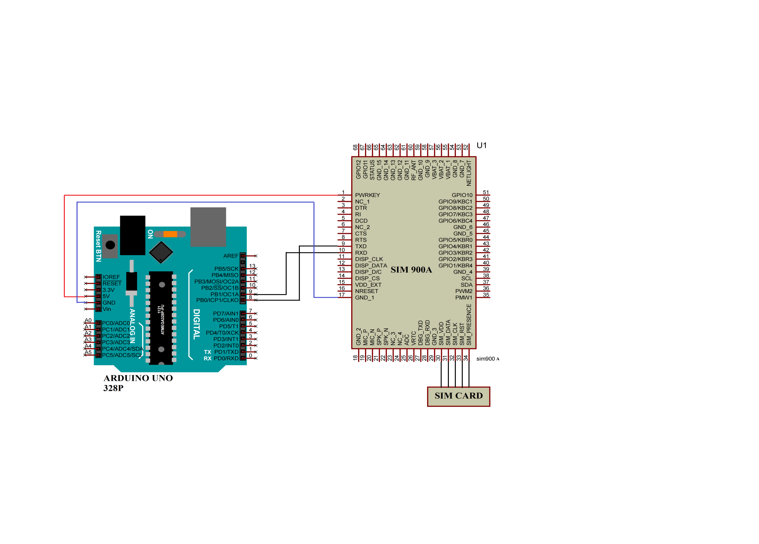

**Fig4.21 :** Interfacing diagram

* 5V and GND pins of Arduino is connected to VCC and GND pins of GSM.
* Tx & Rx of GSM are connected to digital pins (8,9) of Arduino Uno.

**4.6 PH SENSOR:**

**4.6.1 What is pH?**

pH is a measure of the hydrogen ion activity in a solution. Pure water that contains an equal balance of positive hydrogen ions (H+) and negative hydroxide ions (OH-) has a neutral pH.

* Solutions with a higher concentration of hydrogen ions (H+) than pure water are acidic and have a pH less than 7.
* Solutions with a higher concentration of hydroxide ions (OH-) than water are basic (alkaline) and have a pH greater than 7.

**4.6.2 Why Monitor the pH of Water?**

pH measurement is a key step in many water testing and purification processes:

* A change in the pH level of water can alter the behavior of chemicals in the water.
* pH affects product quality and consumer safety. Changes in pH can alter flavor, color, shelf-life, product stability and acid content.
* Inadequate pH of tap water can cause corrosion in the distribution system and can allow harmful heavy metals to leach out.
* Managing industrial water pH environments helps prevent corrosion and damage to equipment.
* In natural environments, pH can affect plants and animals.

Hach offers the testing equipment, resources, training and software to successfully monitor and maintain pH in a wide array of process applications.

**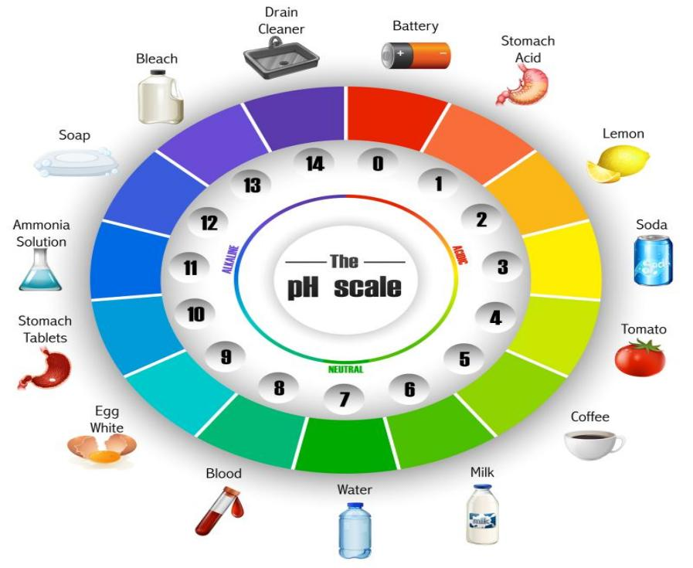**

**Fig4.22:** PH Scale

A high volume, dual junction salt bridge is utilized to maximize the in-service lifetime of the sensor. The

annular junction provides a large surface area to minimize the chance of fouling. Large electrolyte volume and dual reference junctions minimize contamination of the reference solution. The salt bridge is replaceable.

The reference element of the sensor is a second glass pH electrode immersed in a reference buffer solution.

This glass reference system greatly increases the range of sensor applications. An integral pre-amplifier is encapsulated in the body of the sensor. This creates a low impedance signal output which ensures stable readings in noisy environments and increases the maximum possible distance

between sensor and transmitter to 3,000 feet (914meters).

**4.6.3 MEASUREMENT OVERVIEW:**

The Greenspan pH sensor utilizes a robust gel filled industrial pH electrode for field monitoring in a variety of environments.

The pH electrode consists of a pH sensitive glass membrane sealed to a glass insulating tube containing a solution of fixed pH in contact with a silver-silver chloride half cell. The potential developed across the membrane is compared to a stable reference potential eg. a silver-silver chloride half cell in contact with a gel electrolyte containing chloride. Completion of the circuit is by means of a porous constriction (the salt bridge) which allows the reference electrolyte to slowly flow into the sample. The gel electrode is a sealed reference.

pH provides an indication of whether a solution is acidic or basic and is defined as :

pH = - log (H+)

and covers a scale from 0 (acid) to 14 (alkaline) where H+ is the hydrogen concentration in solution, at normal room temperatures.

H2O = H+ +OH-

The concentration of each type of ion is approximately10-7gm molecule/litre and hence the pH of pure water is:

pH = - log 10-7 = 7

**4.6.4 Features:**

* Three different soil test meters in one device; Measures moisture, pH/Acidity, and light.
* 100% Accuracy; Easy to read moisture, pH and light levels; Perfect monitor for growing healthy plants.
* Takes the guesswork out of gardening; Know exactly when to water, amend your soil or adjust lighting.
* Compact, portable & easy to use, just plug and use; Compact soil meter works indoor/outdoors.
* Save water, energy and keep your plants, lawn, flower in top condition.
* Measures moisture at root level.
* No battery required, simple and convenient to use.
* Multifunctional : Can test Moisture / Light / pH.
* Scientifically accurate

**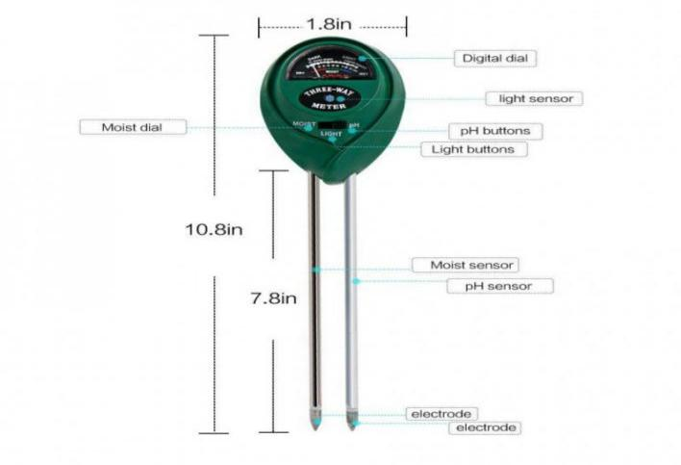**

**Fig4.23:** PH Sensor

**4.6.5 Specifications:**

|  |  |
| --- | --- |
| Moist readings range | 0 DRY-10 WET |
| Light readings range | 0 DARK-2000 LUMEN |
| PH readings range | 8 ALKALINE-3.5ACIDIC |
| Moist value (1-10RH) | 1-3(Red): need to water  4-7(Green): favorable moisture  8-10(Blue): too wet |
| pH value (8-3.5) | Neutral solution : =7  Acid reaction : <7  Alkaline reaction : >7 |
| Light value (0-2000 Lux) | Higher values mean the greater the intensity of the light. |
| Total Length | 250 mm |
| Probe Length | 170 mm |
| Probe Diameter | 5 mm |
| Material | Body: Plastic  Probe:Stainless Steel & Aluminium |
| Color | Green |
| Dimensions in mm (LxWxH) | 260 x 58 x 36 ( Meter Console ) |
| Weight (gm) | 100 |

**Table11:** SPECIFICATIONS

**4.6.6 USE OF THIS PH SENSOR IN THIS PROJECT:**

A pH sensor helps to measure the acidity or alkalinity of the water with a value between 0-14. When the pH value dips below seven, the water starts to become more acidic. Any number above seven equates to more alkaline. Each type of pH sensor works differently to measure the quality of the water. The pH of water can help determine the quality of water.

**4.6.7 WORKING PRINCIPLE:**

The overall working principle of pH sensor and pH meter depends upon the exchange of ions from sample solution to the inner solution (pH 7 buffer) of glass electrode through the glass membrane. The porosity of the glass membrane decreases with the continuous use that decreases the performance of the probe. pH meter is used to determine the pH of different solutions in pharmaceuticals. It is more accurate method then the pH strip. A pH meter contains a pH probe that passes the electrical signals to the pH meter and pH meter displays the pH value of the solution. The glass pH probe contains two electrodes, a sensor electrode and a reference electrode These electrodes are in the form of glass tubes one contains pH 7 buffer and other contains saturated potassium chloride solution. The sensor electode bulb is made up of porous glass or permeable glass membrane coated with silica and metal salts.

**4.6.8 INTERFACING OF PH SENSOR WITH ARDUINO:**

**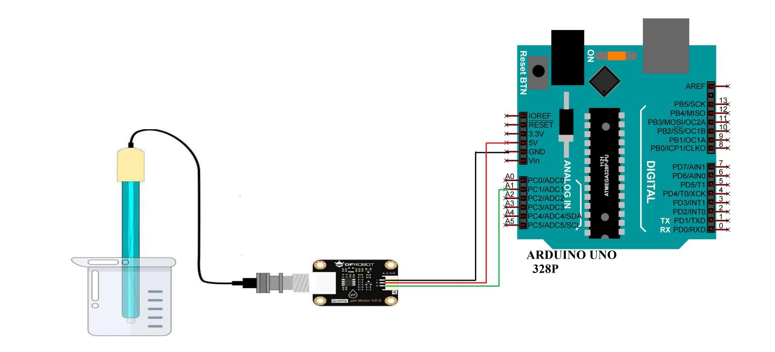**

**Fig4.24:** Interfacing Diagram

* Output pin of PH Sensor is connected to Analog pin(1) of Arduino uno.
* 5V and GND pins of Arduino is connected to VCC and GND pins of PH Sensor.

**4.7 TURBIDITY SENSOR:**

**4.7.1 WHAT IS TURBIDITY?**

Turbidity is the cloudiness or haziness of a fluid caused by large numbers of individual particles that are generally invisible to the naked eye, similar to smoke in the air. The measurement of turbidity is a key test of water quality.

Turbidity is caused by particles suspended or dissolved in water that scatter light making the water appear cloudy or murky. Particulate matter can include sediment, especially clay and silt, fine organic and inorganic matter, soluble colored organic compounds, algae, and other microscopic organisms.

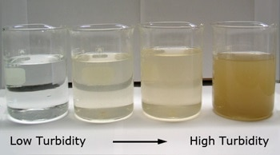

**Fig4.25:** Turbidity

**4.7.2 IMPACT OF TURBIDITY:**

High turbidity can significantly reduce the aesthetic quality of lakes and streams. It can increase the cost of water treatment for drinking and food processing. It can harm fish and other aquatic life by reducing food supplies, degrading spawning beds, and affecting gill function.

**4.7.3 USE OF THIS TURBIDITY SENSOR IN THIS PROJECT:**

In our project Turbidity sensors measure the amount of light that is scattered by the suspended solids in water.

**4.7.4 WHY ONLY TURBIDITY SENSOR?**

Water quality monitoring is the process by which critical characteristics of water (physical,chemical, biological) are measured. Turbidity is one of the most universal metrics of water quality.It is a measure of the cloudiness (the inverse of clarity) of water. In watersheds, the presence of high turbidity can be indicative of both organic and inorganic materials. In the case of organic materials, high turbidity can indicate problems such as increased algae growth caused by fertilizer run-off. In the case of inorganic materials, high turbidity can indicate problems such as high suspended sediment caused by erosion during a rainstorm or water churn caused by high winds. Turbidity is a non-specifific measure and therefore alone cannot identify the root cause of water cloudiness. However, under certain conditions, it can be used to estimate certain quantitative parameters such as stream loading, total suspended solids, and soil loss. There is a variety of published research on the effect of turbidity on different organisms and the implications on human drinking water.

Therefore, turbidity is a useful measure for many water resource management applications.

**4.7.5 SPECIFICATIONS:**

|  |  |
| --- | --- |
| **Working voltage** | DC 5V |
| **Working current** | 30mA [MAX] |
| **Response time** | <500 msec |
| **Insulation Resistance** | 100MΩ [Min] |
| **Operating Temperature (°C)** | -30 ~ +80 |
| **Length (mm)** | 33 |
| **Width (mm)** | 20 |
| **Height (mm)** | 12 |
| **Weight (gm)** | 55 |
| **Shipment Weight** | 0.059 kg |
| **Shipment Dimensions** | 8 × 5 × 5 cm |

#### ****Table12:** specification table**

#### ****4.7.6 FEATURES :****

* Compatible with Arduino, Raspberry Pi, AVR, PIC, etc.
* Measures turbidity of water in rivers.
* Detects and verifies water quality.
* Digital and analog output;
* Able to detect particles that are suspended in water.
* Trimpot for sensitivity adjustment.
* Ideal monitoring of water turbidity in rivers, streams, lakes, water boxes, catchment and research sites, laboratories, tanks with liquids and etc.
* Comes with module and jumpers

**4.7.7 MEASURING TURBIDITY:**

Turbidity is measured using specialized optical equipment in a laboratory or in the field. Light is directed through a water sample, and the amount of light scattered is measured.

The unit of measurement is called a Nephelometric Turbidity Unit (NTU), which comes in several variations. The greater the scattering of light, the higher the turbidity. Low turbidity values indicate high water clarity; high values indicate low water clarity.

**4.7.8 WORKING:**

The Turbidity Sensor emits at its end an infrared light, imperceptible to human vision, capable of detecting particles that are suspended in water, measuring the light transmittance and the dispersion rate, which changes according to the Amount of TSS (Total Suspended Solids), increasing the turbidity of the liquid whenever levels increase.

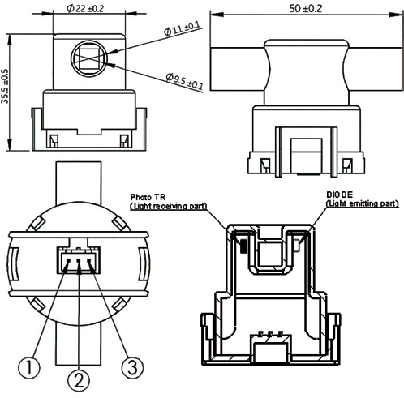 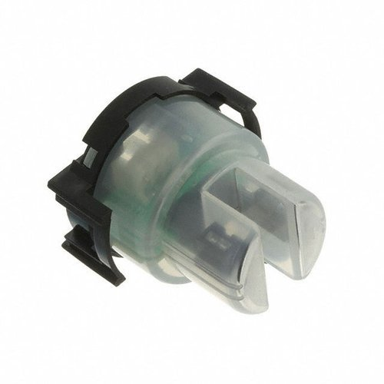

**Fig4.26:** Internal diagram **Fig4.27:**TSD-10

It is very efficient, the Arduino Turbidity Sensor is able to detect and verify the quality of the water, making the turbidity measurement, where it is possible to verify the results by means of digital or analog signal next to the corresponding pins in the accompanying electronic module.

The sensor operates on the principle that when the light is passed through a sample of water, the amount of light transmitted through the sample is dependent on the amount of soil in the water. As the soil level increases, the amount of transmitted light decreases. The turbidity sensor measures the amount of transmitted light to determine the turbidity of the wash water. These turbidity measurements are sent to the dishwasher controller, which makes decisions on how long to wash in all the cycles.

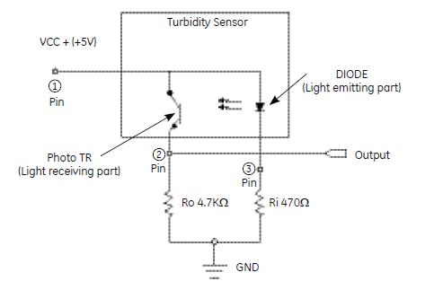

**Fig4.28:** circuit diagram

These decisions are made on the basis of a comparison between clean water measurements. By measuring the turbidity of the wash water, the dishwasher can conserve energy on lightly soiled loads by only washing as long as necessary. This will result in energy savings for the consumer.

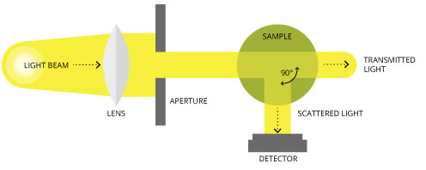 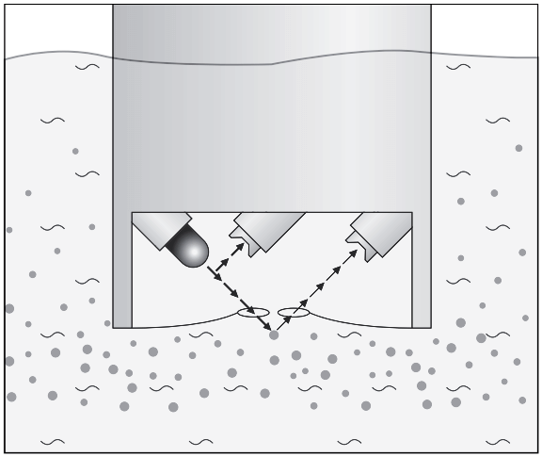

**Fig4.29:**Working Principle  **Fig4.30:** Reflection of light in water

Nephelometry means that the light source and the photo detector are set at a 90-degree angle from each other. This is considered the angle most sensitive to light scatter regardless of particle size.

The device measures scatted light at 90° which is according to ISO 7027 / DIN EN 27027 to be used for turbidity values below 40 NTU.The NIR light source and receiver are positioned in a 90° angle to each other. The light transmitted from the source is directed in equal strength to the reference detector and into the medium. Light is scattered from the particles and the portion which is scattered at a 90° angle is received by the detector. The meter now compares the light from the reference detector and scattered light receiver and calculates the turbidity value.The measurement unit for the turbidity measured at a 90° angle varies depending on country in and is according to ISO 7027 Formazine Nephelometric Unit (FNU), but the more commonly used terminology is Nephelometric Turbidity Unit (NTU) stated within the US EPA 180.1. Both units compare 1 to 1. The advantage of the using NIR as light source as stated in the ISO 7027 is that this sensor is not affected by colour of the medium measured. 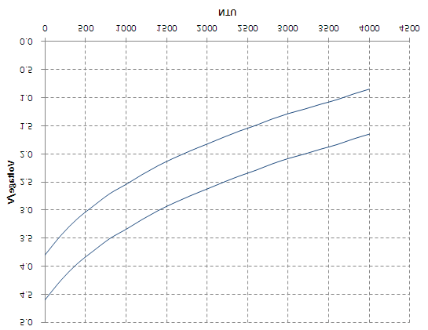

**Fig4.31:** Voltage VS Turbidity Graph

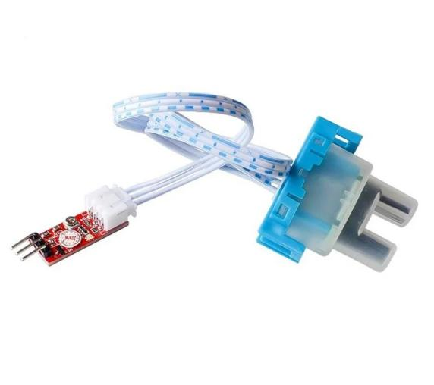 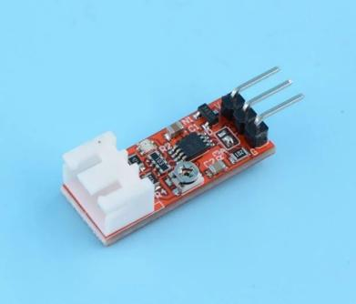 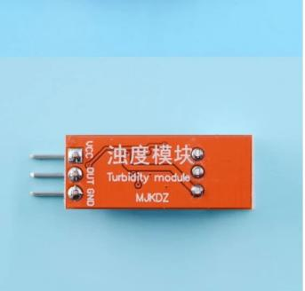

**Fig4.32:**Turbidity sensor **Fig4.33:** SUK SEN 0189

**4.7.9 INTERFACING OF TURBIDITY SENSOR WITH ARDUINO:**

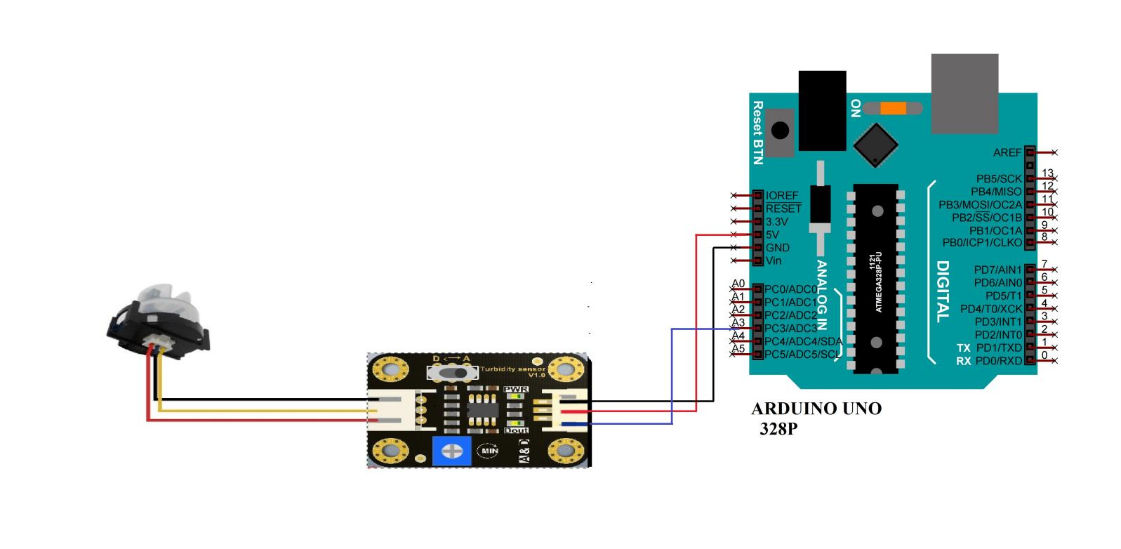

**Fig4.34:** Interfacing Diagram

* Dout of Turbidity Sensor is connected to Analog pin (4) of Arduino uno.
* 5V and ground pins of Arduino is connected to VCC and ground pins of Turbidity Sensor respectively.

**CHAPTER-5**

**CIRCUIT DIAGRAM AND EXPLANATION**

### 5.1 CIRCUIT DIAGRAM:

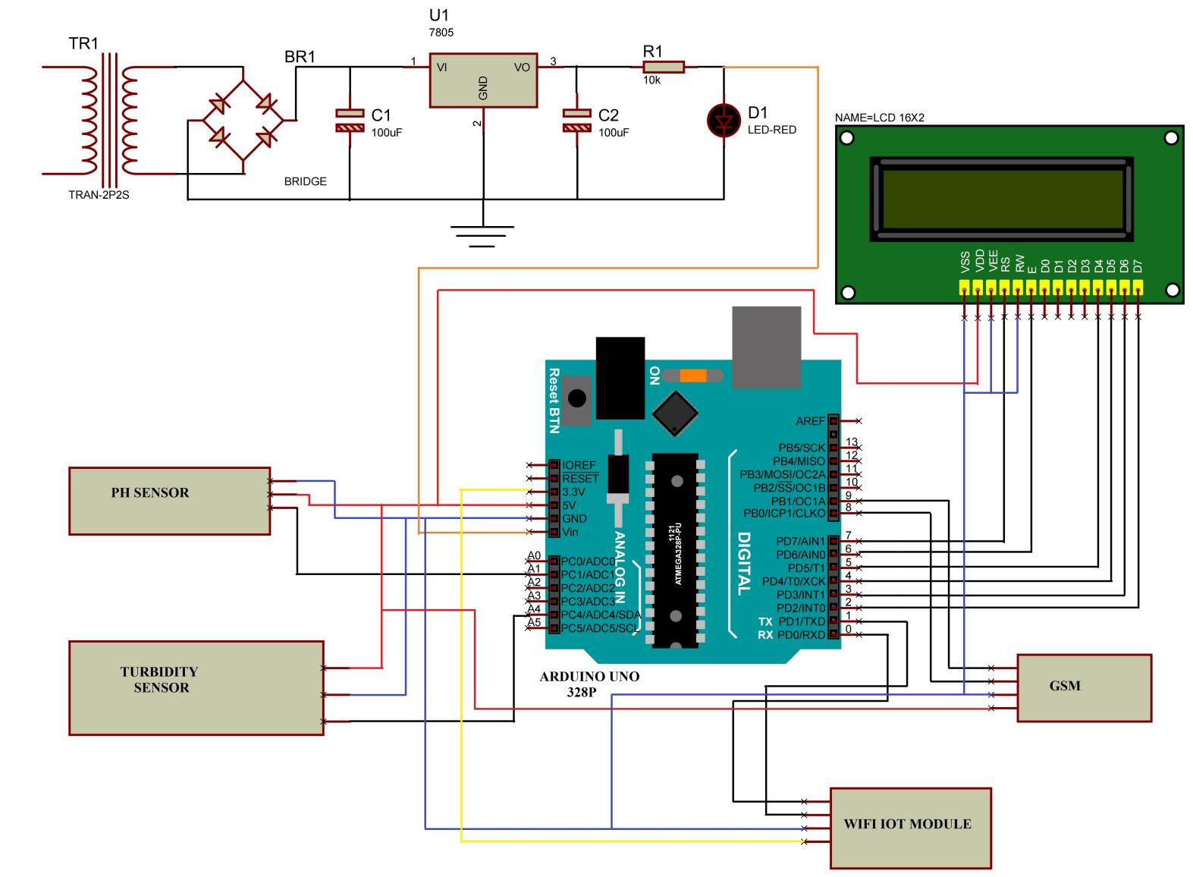

**Fig.5.1** Circuit Diagram

**5.2 Explanation:**

* Vin pin of Arduino is connected to positive Power Supply.
* 5V output pin of Arduino is connected to VDD pin of LCD
* LCD’s Bi-directional data bus D7-D4 pins are connected with digital pins (2-5) of Arduino Uno.
* Register select, Enable pins are connected to digital pins (7,6) of Arduino Uno respectively.
* VDD, RW and VEE pins of LCD are connected to ground.
* 3.3V and ground pins of Arduino is connected to VCC and ground pins of WIFI IOT Module.
* Rx and Tx pins of WIFI IOT Module are connected to Tx and Rx pins of Arduino respectively.
* Dout of Turbidity Sensor is connected to Analog pin (4) of Arduino uno.
* 5V and ground pins of Arduino is connected to VCC and ground pins of Turbidity Sensor respectively.
* Output pin of PH Sensor is connected to Analog pin(1) of Arduino uno.
* 5V and GND pins of Arduino is connected to VCC and GND pins of PH Sensor.
* Tx & Rx of GSM are connected to digital pins (8,9) of Arduino Uno.
* 5V and GND pins of Arduino is connected to VCC and GND pins of GSM.

**CHAPTER-6**

**SOFTWARE SECTION**

**6.1 ARDUINO INTEGRATED DEVELOPMENT ENVIRONMENT (IDE):**

The Arduino Integrated Development Environment (IDE) is a cross-platform application that is written in functions from C and C++. It is used to write and upload programs to Arduino compatible boards, but also, with the help of third-party cores, other vendor development boards.

Arduino Software (IDE) - contains a text editor for writing code, a message area, a text console, a toolbar with buttons for common functions and a series of menus. It connects to the Arduino and Genuino hardware to upload programs and communicate with them.

**Writing Sketches**

Programs written using Arduino Software (IDE) are called sketches. These sketches are written in the text editor and are saved with the file extension ino. the editor has features for cutting/pasting and for searching/replacing text. The message area gives feedback while saving and exporting and also displays errors. The console displays text output by the Arduino Software (IDE), including complete error messages and other information. The bottom right hand corner of the window displays the configured board and serial port. The toolbar buttons allow you to verify and upload programs, create, open, and save sketches, and open the serial monitor.

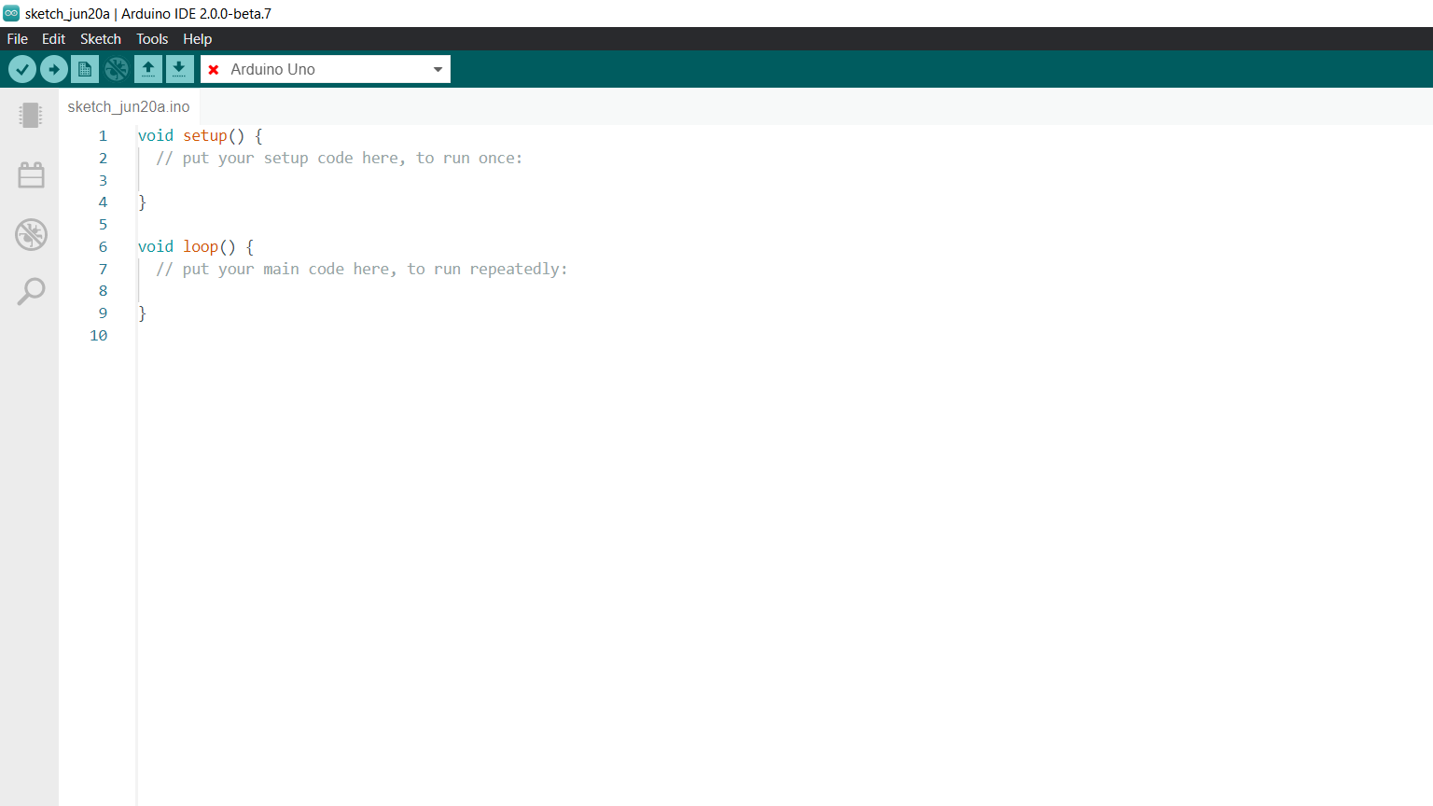

**Fig 6.1** software setup

* [Arduino IDE](https://www.arduino.cc/en/software) is an open source software that is mainly used for writing and compiling the code into the Arduino Module.
* It is an official Arduino software, making code compilation too easy that even a common person with no prior technical knowledge can get their feet wet with the learning process.
* It is easily available for operating systems like MAC, Windows, Linux and runs on the Java Platform that comes with inbuilt functions and commands that play a vital role for debugging, editing and compiling the code in the environment.
* A range of Arduino modules available including [Arduino Uno](https://en.wikipedia.org/wiki/Arduino_Uno), Arduino Mega, Arduino Leonardo, Arduino Micro and many more.
* Each of them contains a [Micro-controller](https://en.wikipedia.org/wiki/Microcontroller) on the board that is actually programmed and accepts the information in the form of code.
* The main code, also known as a sketch, created on the IDE platform will ultimately generate a Hex File which is then transferred and uploaded in the controller on the board.
* The IDE environment mainly contains two basic parts: Editor and Compiler where former is used for writing the required code and later is used for compiling and uploading the code into the given Arduino Module.
* This environment supports both C and C++ languages.

 **Verify:**

* Checks your code for errors compiling it.

 **Upload:**

* Compiles your code and uploads it to the configured board. See uploading below for details.

 **New:**

* Creates a new sketch.

 **Open:**

* Presents a menu of all the sketches in your sketchbook.

 **Save:**

* Saves your sketch.

 **Serial Monitor:**

* Opens the serial monitor.

Additional commands are found within the five menus: File, Edit, Sketch, Tools, Help. The menus are context sensitive, which means only those items relevant to the work currently being carried out are available.

**File:**

**New:**

* Creates a new instance of the editor, with the bare minimum structure of a sketch already in place.

**Open:**

* Allows to load a sketch file browsing through the computer drives and folders.

**Open Recent:**

* Provides a short list of the most recent sketches, ready to be opened.

**Sketchbook:**

* Shows the current sketches within the sketchbook folder structure.

**Close:**

* Closes the instance of the Arduino Software from which it is clicked.

S**ave:**

* Saves the sketch with the current name. If the file hasn't been named before, a name will be provided in a "Save as.." window.

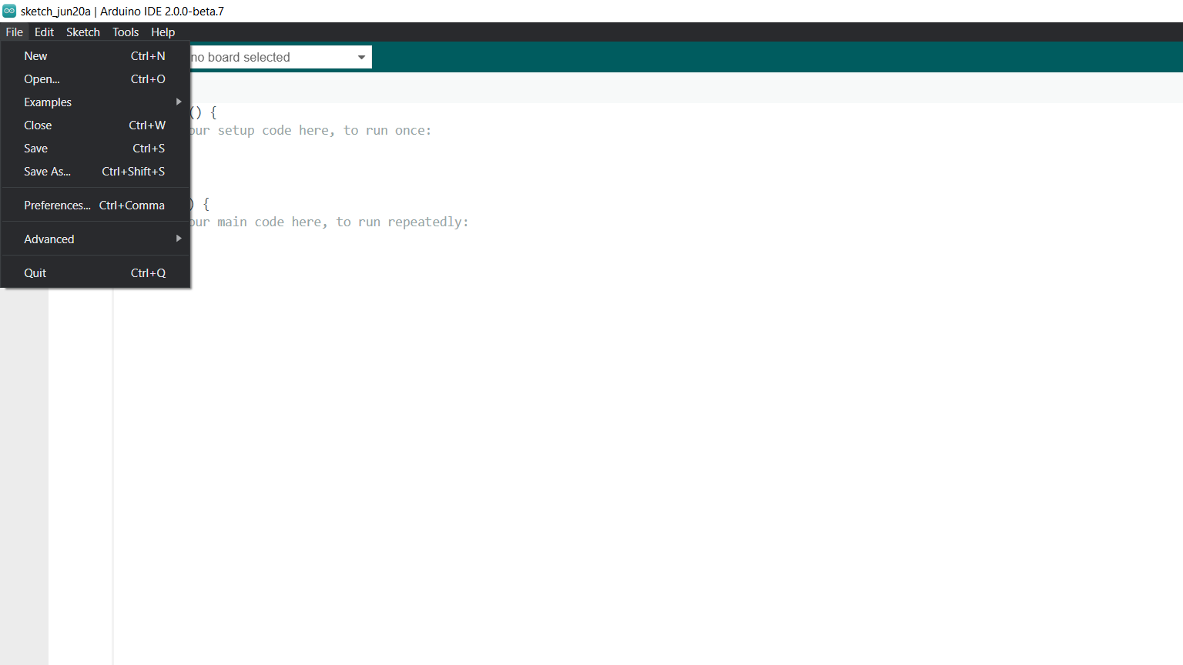

**Fig 6.2** Screen shot

**Save as:**

* Allows to save the current sketch with a different name.

**Page Setup:**

* It shows the Page Setup window for printing.

**Print:**

* Sends the current sketch to the printer according to the settings defined in Page Setup.

**Preferences:**

* Opens the Preferences window where some settings of the IDE may be customized, as the language of the IDE interface.

**Quit:**

* Closes all IDE windows. The same sketches open when Quit was chosen will be automatically reopened the next time you start the IDE.

**Edit:**

**Undo/Redo:**

* Goes back of one or more steps you did while editing; when you go back, you may go forward with Redo.

**Cut:**

* Removes the selected text from the editor and places it into the clipboard.

**Copy:**

* Duplicates the selected text in the editor and places it into the clipboard.

**Copy for Forum:**

* Copies the code of your sketch to the clipboard in a form suitable for posting to the forum, complete with syntax coloring.

**Copy as HTML:**

* Copies the code of your sketch to the clipboard as HTML, suitable for embedding in web pages.

**Paste:**

* Puts the contents of the clipboard at the cursor position, in the editor.

**Select All:**

* Selects and highlights the whole content of the editor.

**Comment/Uncomment:**

* Puts or removes the // comment marker at the beginning of each selected line.

**Increase/Decrease Indent:**

* Adds or subtracts a space at the beginning of each selected line, moving the text one space on the right or eliminating a space at the beginning.

**Find:**

* Opens the Find and Replace window where you can specify text to search inside the current sketch according to several options.

**Find Next:**

* Highlights the next occurrence - if any - of the string specified as the search item in the Find window, relative to the cursor position.

**Find Previous:**

* Highlights the previous occurrence - if any - of the string specified as the search item in the Find window relative to the cursor position.

Sketch:

**Verify/Compile:**

* Checks your sketch for errors compiling it; it will report memory usage for code and variables in the console area.

**Upload:**

* Compiles and loads the binary file onto the configured board through the configured Port.

**Upload Using Programmer:**

* This will overwrite the bootloader on the board; you will need to use Tools > Burn Bootloader to restore it and be able to Upload to USB serial port again. However, it allows you to use the full capacity of the Flash memory for your sketch. Please note that this command will NOT burn the fuses. To do so a Tools -> Burn Bootloader command must be executed.

**Export Compiled Binary:**

* Saves a .hex file that may be kept as archive or sent to the board using other tools.

**Show Sketch Folder:**

* Opens the current sketch folder.

**Include Library:**

* Adds a library to your sketch by inserting #include statements at the start of your code. For more details, see libraries below. Additionally, from this menu item you can access the Library Manager and import new libraries from .zip files.

**Add File:**

* Adds a source file to the sketch (it will be copied from its current location). The new file appears in a new tab in the sketch window. Files can be removed from the sketch using the tab menu accessible clicking on the small triangle icon below the serial monitor one on the right side o the toolbar.

**Tools:**

**Auto Format:**

* This formats your code nicely: i.e. indents it so that opening and closing curly braces line up, and that the statements inside curly braces are indented more.

**Archive Sketch:**

* Archives a copy of the current sketch in .zip format. The archive is placed in the same directory as the sketch.

**Fix Encoding & Reload:**

* Fixes possible discrepancies between the editor char map encoding and other operating systems char maps.

**Serial Monitor:**

* Opens the serial monitor window and initiates the exchange of data with any connected board on the currently selected Port. This usually resets the board, if the board supports Reset over serial port opening.

**Board:**

* Select the board that you're using. See below for descriptions of the various boards.

**Port:**

* This menu contains all the serial devices (real or virtual) on your machine. It should automatically refresh every time you open the top-level tools menu.

**Programmer:**

* For selecting a harware programmer when programming a board or chip and not using the onboard USB-serial connection. Normally you won't need this, but if you're burning a bootloader to a new microcontroller, you will use this.

**Burn Bootloader:**

* The items in this menu allow you to burn a bootloader onto the microcontroller on an Arduino board.

**Sketchbook:**

The Arduino Software (IDE) uses the concept of a sketchbook: a standard place to store your programs (or sketches). The sketches in your sketchbook can be opened from the **File > Sketchbook** menu or from the **Open** button on the toolbar. The first time you run the Arduino software, it will automatically create a directory for your sketchbook. You can view or change the location of the sketchbook location from with the **Preferences** dialog.

**Beginning with version 1.0, files are saved with a .ino file extension. Previous versions use the .pde extension. You may still open .pde named files in version 1.0 and later, the software will automatically rename the extension to **.ino****.

**6.2 FLOW CHART:**

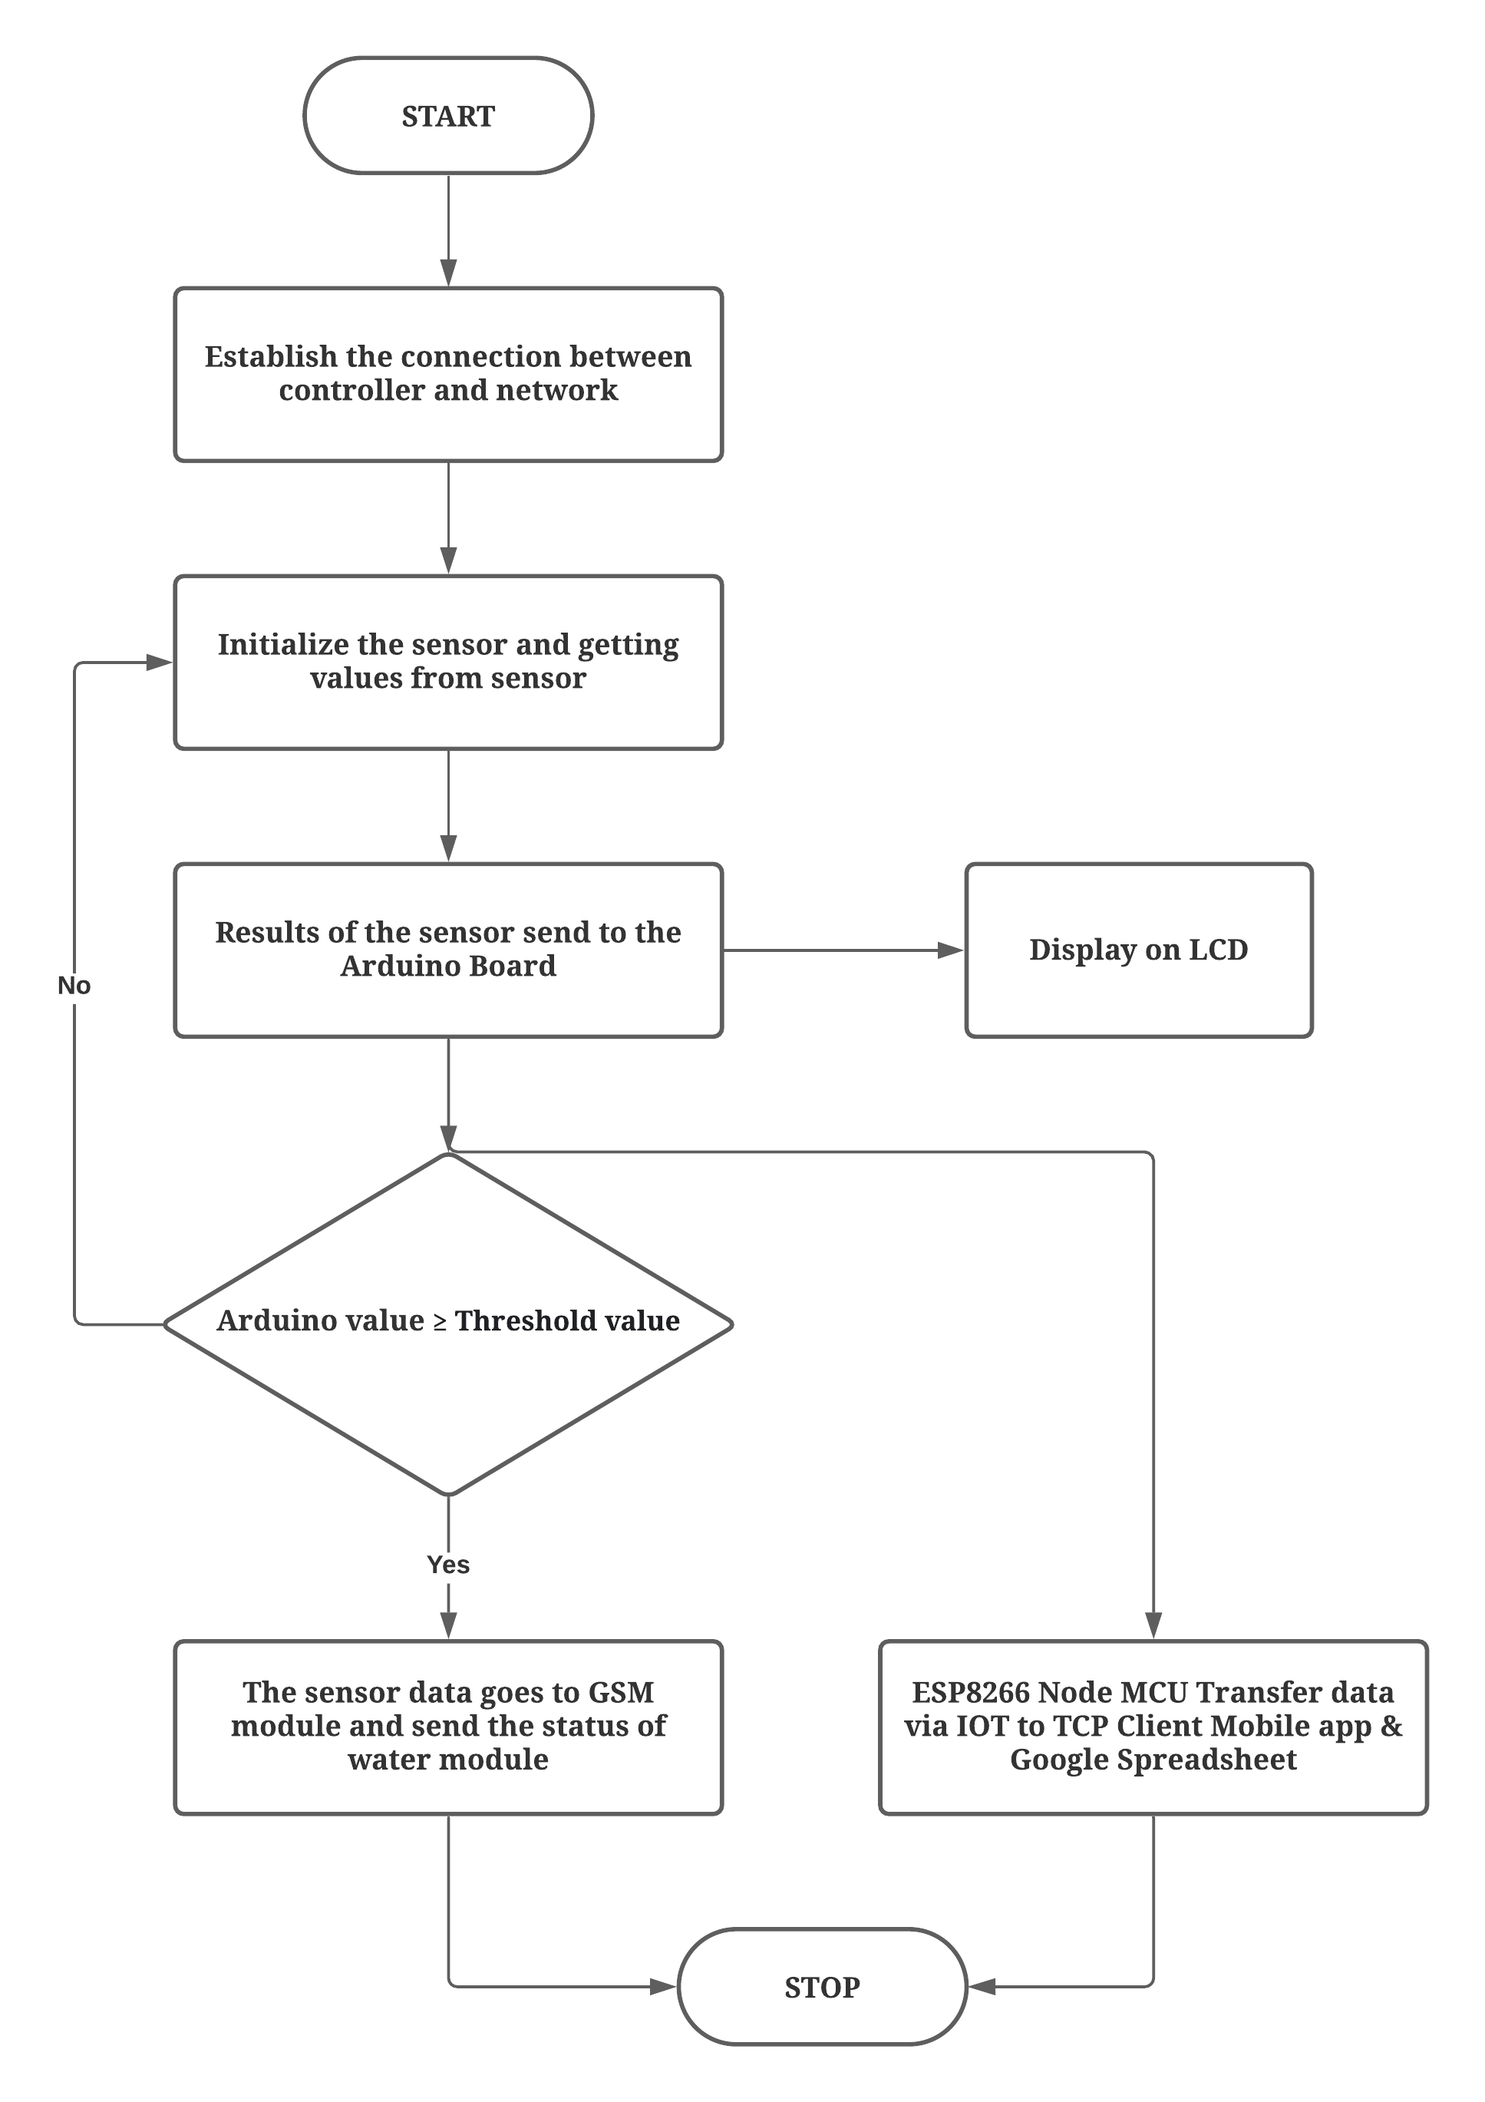

**Fig6.3: F**low chart

**6.2.1 Explanation:**

* The above flow chart shows the complete flow of the System.
* Firstly we need to establish connection between ESP8266 WIFI IOT module with controller which shows on LCD Display “WIFI INIT”.
* Sensors are also initialized which collects the data and send to Arduino uno 328p controller board.
* Resultant sensors are displayed on the LCD display & Values are send to Arduino to compare it with Threshold values.
* All the resultant values are values are stored in Google Spread sheet and also sent to IP Address”192.168.4.1:23” this data can be view on mobile phone with help of TCP Client application these values are used for further analysis of data.
* If the resultant values exceeds then we will get intimation to our mobile number which is declared in Arduino IDE software through GSM module where we have inserted our SIM card.

**CHAPTER-7**

**RESULTS**

images_00

**Fig7.1**:figure represents when the WIFI are initialized properly.

images_01 images_06

**Fig7.2:**It indicated WIFI is connected to the device. **Fig7.3:** Water status in TCP Client

images_02 images_03

**Fig7.4:**figure represents PH value. **Fig7.5:**figure represents Turbidity value.

images_07

**Fig7.6:** This figure represents entire kit connection.

**CHAPTER-8**

**ADVANTAGES & APPLICATIONS**

**8.1 ADVANTAGES:**

Following are the benefits or advantages of IoT based Water Quality Monitoring System are as follows:

* The boat is mobile in nature and hence large number of samples are easily collected from different locations in less time.
* It is very easy to maintain the IoT based water quality monitoring system as all the electronic boards are available in the boat itself.
* The system is very cheap as the hardware and software does not cost much.
* Machine learning techniques have made it very easy to plot the data collected in various formats for proper analysis.
* Cloud storage platforms such as google spread sheet, azure helps in storing the sensor data immediately and wirelessly to the robust servers.

**8.2 APPLICATIONS:**

The applications of IoT in environmental monitoring are broad :

* environmental protection
* extreme weather monitoring
* water safety
* endangered species protection
* commercial farming

**CHAPTER-9**

**CONCLUSION & FURTURE SCOPE**

**9.1 CONCLUSION:**

The Project “An IoT based system for water quality monitoring” has been successfully designed and experimented. We have seen the success of sensors in various fields,Monitoring of Turbidity, PH of Water makes use of water detection sensor with unique advantage and existing GSM network. The system can monitor water quality automatically, and it is low in cost and does not require people on duty. So the water quality testing is likely to be more economical, convenient and fast. The system has good flexibility. Only by replacing the corresponding sensors and changing the relevant software programs, this system can be used to monitor other water quality parameters. The operation is simple. In this paper we have analysis different water quality monitoring systems to do the same. All these techniques are expensive and difficult in terms of analysis and collecting the data.

**9.2 FURTURE SCOPE:**

The future scope of this project is monitoring environmental conditions, drinking water quality, treatment and disinfection of waste water etc. This system could also be implemented in various industrial processes.Analysis of data makes easier Providing accurate and timely information on the quality of water & helps in providing total data regarding the purity of water is displayed on the web page and is analyzed in the form of a graph, pie chart and values are given in the table.

**APPENDICES**

**APPENDIX-A:CODE**

#include <LiquidCrystal.h>

#include <SoftwareSerial.h>

// initialize the library with the numbers of the interface pins

LiquidCrystal lcd(7, 6, 5, 4, 3, 2);

SoftwareSerial mySerial(8, 9); //GSM

const int ph = A0;

const int turbidity = A1;

int sensor1Value = 1;

int sensor2Value = 1;

void sendwifi(String chr, unsigned int len)

{

String temp[20];

Serial.print("AT+CIPSEND=0,");

Serial.println(len);

delay(1000);

Serial.println(chr);

delay(2000);

}

void setup() {

pinMode(ph, INPUT);

pinMode(turbidity, INPUT);

lcd.begin(16, 2);

lcd.clear(); lcd.setCursor(0, 0); lcd.print("welcome");

Serial.begin(9600);

delay(1000);

lcd.clear(); lcd.setCursor(0, 0); lcd.print("WIFI INIT");

Serial.print("AT\r\n");

delay(1000);

Serial.print("ATE0\r\n");

delay(1000);

Serial.print("AT+CIPMUX=1\r\n");

delay(1000);

Serial.print("AT+CIPSERVER=1,23\r\n");

delay(1000);

lcd.clear(); lcd.setCursor(0, 0); lcd.print("192.168.4.1");

lcd.setCursor(0, 1); lcd.print("Port: 23");

delay(1000);

lcd.clear(); lcd.setCursor(0, 0); lcd.print("CONNECTED");

sendwifi("WELCOME\r\n", 9);

delay(1000);

mySerial.begin(9600);

delay(500);

while (!Serial) {

; // wait for serial port to connect. Needed for Leonardo only

}

mySerial.println("AT");

delay(1500);

mySerial.println("AT+CREG?");

delay(1500);

mySerial.println("AT+CMGF=1");

delay(1500);

mySerial.println("AT+CNMI=1,2,0,0");

delay(1500);

}

void loop() {

// lcd.begin(16, 2);

// lcd.display();

// lcd.setCursor(0, 0);

// lcd.print("COLLISION" );

// lcd.setCursor(0, 1);

// lcd.print(" AVOIDANCE" );

sensor1Value = analogRead(ph) / 100;

sensor2Value = analogRead(turbidity);

int turbidity = map(sensor2Value, 0, 750, 100, 0);

delay(100);

lcd.begin(16, 2);

lcd.print("PH:= " );

lcd.print(sensor1Value);

delay(1000);

Serial.print("AT+CIPSEND=0,");

Serial.println(8);

delay(1000);

Serial.println("\r\nPH : ");

delay(1000);

Serial.print("AT+CIPSEND=0,");

Serial.println(4);

delay(1000);

Serial.println(sensor1Value);

delay(1000);

lcd.begin(16, 2);

lcd.print("turbidity:= " );

lcd.print(sensor2Value);

delay(1000);

Serial.print("AT+CIPSEND=0,");

Serial.println(8);

delay(1000);

Serial.println("\r\nturbidity : ");

delay(1000);

Serial.print("AT+CIPSEND=0,");

Serial.println(4);

delay(1000);

Serial.println(sensor2Value);

delay(1000);

if (sensor1Value > 8)

{

lcd.begin(16, 2);

lcd.clear(); lcd.setCursor(0, 0);

// lcd.setCursor(0, 1);

lcd.print("pH Value is High");

sendwifi("\r\nHIGH pH DETECTED\r\n", strlen("\r\nHIGH pH DETECTED\r\n"));

delay(1000);

mySerial.println("AT+CMGS=\"9700082044\"\r\n");

delay(1500);

mySerial.println("HIGH pH DETECTED\r\n");

mySerial.println((char)26); delay(500);

}

if (turbidity < 20) {

lcd.begin(16, 2);

lcd.clear(); lcd.setCursor(0, 0);

//lcd.setCursor(0, 1);

lcd.print(" its CLEAR ");

sendwifi("\r\n its CLEAR \r\n", strlen("\r\n its CLEAR \r\n"));

delay(1000);

mySerial.println("AT+CMGS=\"9700082044\"\r\n");

delay(1500);

mySerial.println("turbidity: its CLEAR \r\n");

mySerial.println((char)26); delay(500);

}

if ((turbidity > 20) && (turbidity < 50)) {

lcd.begin(16, 2);

lcd.clear(); lcd.setCursor(0, 0);

// lcd.setCursor(0, 1);

lcd.print(" its CLOUDY ");

sendwifi("\r\n its CLOUDY \r\n", strlen("\r\n its CLOUDY \r\n"));

delay(1000);

mySerial.println("AT+CMGS=\"9700082044\"\r\n");

delay(1500);

mySerial.println("turbidity: its CLOUDY \r\n");

mySerial.println((char)26); delay(500);

}

if (turbidity > 50) {

lcd.begin(16, 2);

lcd.clear(); lcd.setCursor(0, 0);

// lcd.setCursor(0, 1);

lcd.print(" its DIRTY ");

sendwifi("\r\n its DIRTY \r\n", strlen("\r\n its DIRTY \r\n"));

delay(1000);

mySerial.println("AT+CMGS=\"9700082044\"\r\n");

delay(1500);

mySerial.println("turbidity: its DIRTY \r\n");

mySerial.println((char)26); delay(500);

}

}

**APPENDIX-B:REFERENCES**

* M.F. Saaid, A.Sanuddin, Megat Ali “Automated ph controller system for hydroponic cultivation” Symposium on computer applications and industrial electronics(ISCAIE) IEEE, pp.186-190,2015.
* Lakshmanan, L. and Jalasri., (2019), “A Survey: Integration of IoT and Fog Computing”, IEEE International Conference on , ICCSP 2018, IEEE Conference Proceeding International Conference on Green Computing and Internet of Things (ICGCIoT),pp. 0235 - 0239, DOI: 10
* Ayushi S.jaiswal, Vaidehi Baporikar “Embedded wireless data acquisition syatem for unnamed vehicle in underwater” IEEE underwater technology, vol 10,pp.1-6,2015.
* F Ntambi, C P kruger, B J silva “Design of a water management system” AFRICON IEEE pp.1-5,2015
* Jesudoss A., Muthuram B.O. and Lourdson Emmanuel A., “Safe Driving using IoT Sensors”, conducted by International Conference on Engineering and Advancement in Technologies (ICEAT 2018), conduted by Sri Krishna College of Technology, Kovaipudur, Coimbatore
* Ji wang, Xiao-liRen, Yu-lishen “A Remote wireless sensor networks for water quality monitoring” International conference on innovative computing and communication, IEEE pp.7-12, 2010
* Cheng-Liang Lai, Chien-Lun chiu “Using image processing technology for water quality monitoring system” International conferenceonmachine learning and cybernetics.IEEE pp.1856- 1861,2011.
* Lakshmanan, L. and Jesudoss and Ulagamuthalvi, (2018), “Cluster Based Routing Scheme for Heterogeneous Nodes in WSN–A Genetic Approach”,ICICI 2018: International Conference on Intelligent Data CommunicationTechnologies and Internet of Things (ICICI) 2018,LNDECT, volume 26,pp 1013-1022
* Aravindan S.Rao, Stephan Martial, Jayavardhan Gubbi, “Design of low cost autonomous water quality monitoring system” International conference on advances in computing communications and informatics(ICACCI) IEEE,pp.14-19.2013.
* H Doukkali, L Nuaymi, “Analysis of MAC protocols of underwater sensor networking” Vehicular Technology conference UTC 2005 IEEE 61st,vol.2,pp.1307-1311,2005
* IF Akyildiz, D pompili, T Melodia,”Underwater acoustic sensor networks:research challenges”, Ad hoc Networks,vol.3,no.3,pp.257- 259,2005.
* Jesudoss A., R. Vybhavi and B. Anusha, “Design of Smart Helmet for Accident Avoidance”, IEEE International Conference on Communciations and Signal Processing, organized by Adhiparasakthi Engineering College, Chennai, April 4 to 6, 2019.
* I.Vasilesu, K.Kotay, D.Rus, P.Corke “Data collection storage and retrieval with an underwater sensor network”, IEEE Sensys, pp.154-165, 2005.
* Niel Andre Cleote, Reza Malekian and Lakshmi nair “Design of smart sensors for real time water quality monitoring” IEEE Access vol-4,no.9, pp.1-16,2014.
* P-Jiang, H.Xia, Z.He, Z-Wang “Design of a water environment monitoring system based on wireless sensor networks”, Sensors,Vol.9,no.8,pp.6411-6434,2009.

**APPENDIX-C:BIOGRAPHY**



NAME: CH K CHAITANYA

HT.NO:17831A0414

CONTACT NO:9948344091

E-MAIL:Chaitanya7c@gmail.com



NAME:K RAJA

HT.NO:17831A0435

CONTACT NO:9666800736

E-MAIL: maminiraja.0904@gmail.com



NAME: K SAITEJA

HT.NO:17831A0436

CONTACT NO:8977767167

E-MAIL:kanikesaiteja@gmail.com